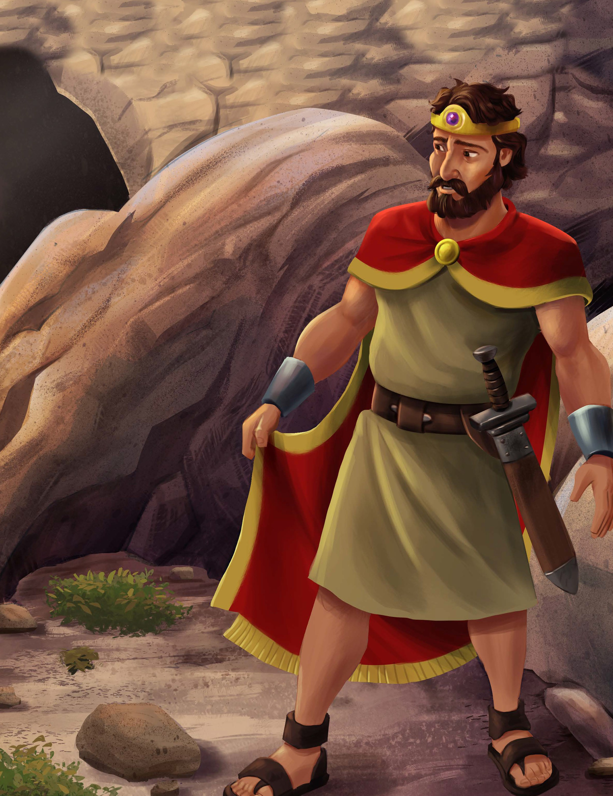
UNIT 1 1 | SESSION 2

DAVID SHOWED MERCY
1 S AMUEL 2 4

KEY PASSAGE: Jeremiah 10:6-7a

BIG PICTURE QUESTION: Is anything or anyone greater than God? No, God is greater than everything and everyone.

CHRIST CONNECTION: Saul was trying to kill David, but David chose to show Saul mercy. When the people were killing Jesus, He showed them mercy and said, “Father, forgive them.” We all sin, but God shows us mercy through Jesus, who died for our sin and rose again.

STORY POINT: David showed mercy even though Saul was trying to hurt him.

Older Kids Leader Guide | Unit 11 • Session 2 | 64
© 2025 Lifeway

P RIOR T O TEA CHING THE SESSION


LEADER Bible Study

PREPARE
THE WEEK PRIOR
Prepare your heart to teach; plan the session
In 1 Samuel 24, we see the tension between Saul and David come to a head, as David turned down an opportunity to rid himself of King Saul once and for all. We see David’s heart for the Lord as he chose to pursue obedience over safety. David’s mercy in this story shows us a glimmer of Christ’s incredible mercy toward sinners who place their faith in His name.
Why did David spare Saul’s life? How do we see an even greater pardon for sin in the lives of Christ followers?

WELCOME
10–15 MINUTES
Greet kids and open the session
Back in chapter 18, Saul had begun growing jealous of David’s popularity after his many victories in battle. By chapter 24, Saul had attempted to kill David multiple times and refused to give up the fight. In fact, he brought 3,000 men on a mission to search for David in the wilderness of En-gedi. David soon found himself in a cave with his own men, who tempted him to kill the vengeful King Saul.
Yet, David knew what the Lord called him to do (1 Samuel 24:6). He extended honor to Saul, though he did not deserve such mercy. David even swore to never harm his king, an oath that would continue to be tested as Saul would go back on his word to preserve the life of his young successor.

LEARN
25–30 MINUTES
Teach kids the story of the gospel
David trusted God to deliver him from Saul and refused to take matters into his own hands, believing God’s word would come to pass and that David would become king in God’s perfect timing. David’s willingness to grant mercy came from his trust in God’s perfect justice and righteousness (v. 15). Rather than seek vengeance, David extended mercy, recognizing God alone would enact judgment on Saul’s sin.
In an even greater act of mercy, Christ died for sinners. He prayed for forgiveness for those who nailed Him to the cross and took the judgment for our sin. The mercy of God is available to all who place their faith in Jesus Christ (Ephesians 2:4-5). Lead boys and girls to see the immeasurable gift of Christ’s mercy; that they, too, would experience forgiveness of sins and new life in Christ Jesus.

Lead kids to love the God of the gospel
15–20 MINUTES
LOVE



Lead kids to live out the mission of the gospel
15–20 MINUTES
LIVE

David Showed Mercy | 65

P RIOR T O TEA CHING THE SESSION

GATHER Supplies


Keep a regular supply of the following items available at all times: Bibles, pens or pencils, markers, crayons, colored pencils, scissors, glue or tape, paper.
LOVE
Review & Bible Skills
D Small Group Timeline and Map Set
LIVE
Activity Choice (Option 1)
D 1-inch clear glass stones with flat back, also known as cabochons, 1 per kid
D “Mercy Magnets” printable
D self-adhesive magnetic dots, 1 per kid
Journal and Prayer
D Journal Page
D “God Is Merciful” activity page
WELCOME
Activity Page
D “Find the Way” activity page
Session Starter (Option 2)
D vinegar D plastic baggie D baking soda D baking tray
D 1/2 sheet paper towel

Older Kids Leader Guide | Unit 11 • Session 2 | 66
LEARN
Introduce the Session D countdown video D Story Point Poster
Big Picture Question
D Big Picture Question Poster
Review the Timeline
D Giant Timeline
Tell the Bible Story
D “David Showed Mercy” video
D Bible Story Picture Poster
Questions from Kids
D “Unit 11, Session 2” Questions from Kids video
Missions Moment
D “Portrait of a Neighborhood” missions video
Key Passage Activity
D Key Passage Poster
D “You Are Great, You Are Great (Jeremiah 10:6-7a)” song
D worship song of your choice (optional)

WELCOME Kids
Greet each kid as he or she arrives. Use this time to collect the offering, fill out attendance sheets, build relationships, and help new kids connect to your group.

SAY Has anyone ever hurt your feelings? What did you do in response?

ACTIVITY PAGE (5 minutes)
Invite kids to complete “Find the Way” activity page.

SAY Today, we will see how David hid in a cave because Saul was trying to hurt him.

SESSION STARTER (10 minutes)

- OPTION 1: SHOW MERCY
Tell kids that mercy means to not give someone a consequence they deserve, such as punishment for sin. Share how God shows people mercy when He forgives their sin and doesn’t give them the punishment they deserve. Call out a list of scenarios,
and invite kids to describe how mercy could be displayed in each situation. Consider the following examples, or choose your own:
  - A girl left her homework on the bus.
  - A mom burned the family’s dinner.
  - A boy was made fun of by his peers.
  - A dad broke a promise to his son.
  - A neighbor accidentally hit your mailbox.
SAY God is merciful. He generously shows sinners mercy when He forgives them through their faith in Jesus. God desires that we show mercy to others as well because it helps others see what God is like and brings Him glory.
Today, we will see how David showed mercy even though Saul was trying to hurt him.
- OPTION 2: EXPLODING ENVY
Fill a plastic sandwich baggie with 1/2 cup of vinegar. Seal the baggie. Then take a half sheet paper towel, and place 2 tablespoons of baking soda in the paper towel. Tell
kids that the paper towel with baking soda represents envy or jealousy. Discuss how when we allow jealousy to rule our hearts, we can have “explosive” reactions of anger, frustration, and ungratefulness. Fold up the paper towel with baking soda, and place it in the baggie. Quickly seal the baggie tight, and place it on a baking tray. Watch as the baggie fills up with gas and pops open.
SAY When someone is jealous, they want something someone else has. In today’s Bible story, we will see that Saul was jealous of David because David was being praised by the people. Saul wanted to have all the praise for himself. Instead of seeking to honor God, Saul allowed his jealousy to explode into violence. He chased after David and tried to kill him.
Let’s hear our Bible story to learn how David responded to Saul’s jealousy and hatred.





Transition from WELCOME to LEARN

David Showed Mercy | 67

THE ST OR Y OF THE GOSP EL

INTRODUCE the Bible Story
INTRODUCE THE SESSION (3 minutes)
Show the countdown video as you transition to introduce the Bible story. Set it to end as the session begins.
SAY Hi, kids! My name is [your name], and I’m glad you are here so we can study God’s Word together. If you have a Bible with you, will you take it out? [Distribute Bibles to kids who need one.] Today, we will be in the Old Testament book of 1 Samuel. [Invite kids to find 1 Samuel 24 in their Bibles.]
As we hear our story, we will see how David showed mercy even though Saul was trying to hurt him. [Display the Story Point Poster.] Let’s pray and ask God to prepare our hearts to hear from His Word: ‘Lord, thank You for Your mercy through Jesus Christ. Help us understand how Your mercy leads us to show mercy to others. In Jesus’ name, amen.’

BIG PICTURE QUESTION (1 minute)
Display the Big Picture Question Poster.
SAY Do you remember the big picture question we learned last week? [Allow responses.] Is anything or anyone greater than God? What is the answer? [Allow responses.] No, God is greater than everything and everyone. Let’s say the answer again: No, God is greater than everything and everyone.

God is greater than anyone and everything, not just because He is all-powerful, but also because He is holy. This means everything God is and does is right and without sin. Part of God’s holy character also means He is merciful. Throughout the Bible, God revealed His character as merciful by how He responded to people. God showed people mercy by forgiving them, even when they deserved punishment for their sin. More specifically, God has shown believers mercy through His Son, Jesus. He calls believers to show His mercy to others because they have experienced mercy through faith in Jesus.

REVIEW THE TIMELINE (1 minute)
Show the Giant Timeline. Point to individual Bible stories as you review.

SAY David was a young shepherd boy when he was anointed to be the next king of Israel. Last week, we learned how David defeated Goliath with God’s power. God was with David and gave him victory in other battles he fought. Today, we will discover how David continued to trust in God while he was chased by King Saul. Instead of harming King Saul, David chose to do what was right in God’s eyes and showed mercy to Saul.

Older Kids Leader Guide | Unit 11 • Session 2 | 68

THE ST OR Y OF THE GOSP EL

LEARN the Bible Story

TELL THE BIBLE STORY: VIDEO OR STORYTELLER (10 minutes)
Open your Bible to 1 Samuel 24. Use the Bible storytelling tips to help you tell the story, or show the Bible story video “David Showed Mercy.” Use the bold text to retell or review the story.

DAVID SHOWED MERCY
David became a great military leader for the Israelites and was more successful in battle than all of Saul’s army. Saul was very jealous of David. Saul was hunting down David to kill him, because he did not want David to become king instead of him.

While Saul and his army chased after David to kill him, Saul went into a cave to go to the bathroom. It just so happened that he went into the very cave where David and his men were hiding. Saul did not see David and the men in the cave.
The men whispered to David: “Look, the Lord has handed Saul over to you, just as He said He would.” David snuck up behind Saul while he was going to the bathroom and cut off a corner of his robe.
Afterward, David felt terrible for cutting off a corner of Saul’s robe. David said to his men: “I should have never done such a thing to a man anointed by the Lord!” The men wanted to go fight Saul, but David did not let them.
Then Saul left the cave and went on his way. David followed him out of the cave and called to him, saying, “My lord the king!” When Saul turned around, David knelt low before him and said, “Why do you listen to the people who say I want to hurt you? I could have killed you in the cave, but I showed mercy

because you are the Lord’s anointed. See, I have the corner of your robe in my hand! I cut it off, but I didn’t kill you. I haven’t sinned against you even though you are hunting me down to take my life.”
David told Saul that God is their judge. Only God could decide what is right and rescue David from Saul. Then David said he would never harm Saul.
Saul wept and said to David, “You are more righteous than I am. You have done good to me even though I have done evil to you. May the Lord repay you with good for what you’ve done for me today. Now I know for certain you will be king over the kingdom of Israel.”

Christ Connection: Saul was trying to kill David, but David chose to show Saul mercy. When the people were killing Jesus, He showed them mercy and said, “Father, forgive them.” We all sin, but God shows us mercy through Jesus, who died for our sin and rose again.

STORYTELLING TIPS
Tear: Hold up a piece of fabric, and cut the corner of it when you describe how David cut Saul’s robe.
Define it: Tell kids that righteous means to do what is right and good. Remind kids that God is always righteous.

David Showed Mercy | 69

THE ST OR Y OF THE GOSP EL

REVIEW THE BIBLE STORY
SAY King Saul began to chase after David to kill him. Why did Saul want to kill David? Look at 1 Samuel 18:6-9. [Ask a volunteer to read aloud 1 Samuel 18:6-9.] As the people praised David for

his military successes, Saul became jealous of David. He disliked how much attention and applause David received. Saul’s jealousy became so great that he wanted to kill David. The Bible tells us those who make a practice of jealousy will not inherit the kingdom of God (Galatians 5:20). Continuous, unrepentant jealous behavior reveals a heart that does not love God and others. Those who have trusted in Jesus walk by the Holy Spirit and desire to show love, mercy, and forgiveness.
What did David do to show mercy toward Saul? Look at 1 Samuel 24:5-7 [Ask a volunteer to read aloud 1 Samuel 24:5-7.] David had an opportunity to hurt Saul while he was in the cave. Even
though David only cut off a corner of Saul’s robe, David’s conscience bothered him. David promised never to harm Saul or allow his men to hurt Saul. David showed mercy even though Saul was trying to hurt him.
Why do you think Saul said David was more righteous than him? Loot at 1 Samuel 24:17-18. [Ask a volunteer to read aloud 1 Samuel 24:17-18.] Saul said that David was more righteous than him because David had done what was good to Saul even when Saul did what was evil to David. This reminds me of Jesus, who did what was good for us, even when people did what was evil to Him. When the people were killing Jesus, He showed them mercy and said, ‘Father, forgive them.’ We all sin, but God shows us mercy through Jesus, who died for our sin and rose again.

GOSPEL DISCUSSION

SAY Even though we have sinned against God, God showed us mercy by sending His Son, Jesus, to die on the cross to pay the penalty for our sin. In Romans 6:23, we learn we deserve death for our sins, but Jesus’ death was God’s merciful act toward us. When we put our faith in Him, we receive mercy and forgiveness for our sins. Have you received God’s mercy and accepted Jesus as your Savior?
(Tip: Use Scripture and the Gospel Plan Poster to explain how to become a Christian. Create an environment where kids are welcome to ask questions about what it means to follow Jesus.)

QUESTIONS FROM KIDS (3 minutes)
Show the “Unit 11, Session 2” Questions from Kids video. Prompt kids to discuss:
- What if someone was bullying us; should we bully back?
- How does the good news of Jesus change how we treat others?

MISSIONS MOMENT (3 minutes)

SAY A small town called Clarkston, Georgia, is known as the most diverse square mile in America because people from many different countries live in the area. Between 60–70 percent of the people living in Clarkston were born in another country. More than 50 countries and 100 ethnic

Older Kids Leader Guide | Unit 11 • Session 2 | 70

THE ST OR Y OF THE GOSP EL

groups are represented in a 1.4 square-mile area. There are 60 languages spoken in this small area outside of Atlanta. Many of the people living in Clarkston are refugees. A refugee is a person who has been forced to leave their country in order to escape war, persecution, or natural disaster.
Play the missions video. Tell kids that an organization called the Atlanta Ministry Center works with local churches and volunteers to serve the refugees living in Clarkston. Explain that when refugees come to a new country, they may not have a place to live, food, or other basic necessities. The Atlanta Ministry Center helps provide refugees with food, shelter, and safety. They also provide classes to teach the people English, give them job-skills training, do after-school tutoring, and provide other assistance to help people adjust to living in a new country and culture. The people working at the Atlanta Ministry Center share the good news of Jesus as they serve the refugees. Pray that many people will hear the gospel and trust in Jesus as their Savior.

KEY PASSAGE ACTIVITY (5 minutes)
Show the Key Passage Poster. Lead kids in reading aloud Jeremiah 10:6-7a together.

SAY God is the greatest because no one is holy and righteous like Him. David also recognized that God is great and chose to trust in His righteousness, rather than seek vengeance on Saul.
Form kids into pairs. Provide a kid in each pair with a piece of paper and a pen. Guide pairs to stand 6–10 feet away from one another. Lead the kids with the paper to write the first few words of the key passage on the paper. Then direct them to fold the paper into a paper
airplane. Kids will toss the airplane to their partner who will then unfold it, write the next few words, and toss the airplane back. Continue until all the words have been written.
Lead kids to sing “You Are Great, You Are Great (Jeremiah 10:6-7a).” You may also choose to sing a worship song of your choice.

PRAY (2 minutes)
Invite kids to pray before transitioning to Love.

SAY Dear God, thank You for showing mercy to us through Your Son, Jesus, when we sin against You. Help us show mercy to others and point them to Jesus. In Jesus’ name, amen.


Transition from LEARN to LOVE

David Showed Mercy | 71

THE GOD OF THE GOSP EL

LOVE God by Applying the Story
REVIEW & BIBLE SKILLS (5 minutes)
Distribute Bibles, and display the Old Testament Kingdoms Map. Guide kids to open their Bibles to 1 Samuel 24. Consider pointing out the Wilderness of En-gedi (J5), near the southwest side of the Dead Sea, on the Old Testament Kingdoms Map. Tell kids the En-gedi had rocky terrain and waterfalls. Share how it also had many plants and vineyards. Share how the En-gedi was a place of safety for David.
Choose a volunteer to read aloud 1 Samuel 24:11-12, or ask the kids to follow along as you read the verses aloud.

SAY David reminded King Saul of his innocence. David had not committed a crime or sinned against Saul. Yet, because of Saul’s jealousy, he wanted to kill David. Rather than hurt Saul, David trusted that God would judge rightly and see that Saul’s actions were wicked.
Jesus never sinned or committed a crime, and yet the people crucified Him on a cross. Not only did Jesus trust God completely, but it was God’s plan for Jesus to die on the cross to save sinners. When we trust in Jesus, we are freed from the punishment our sin deserves.

GROUP DISCUSSION (10 minutes)
Ask the following questions. Lead the group to discuss.

SAY Why is jealousy a sin?
Discuss how jealousy is connected to coveting (Exodus 20:17). When we want something someone else has, we reveal what our heart desires most or what it idolizes. Saul’s jealousy lead to a murderous pursuit of David. The idol of his heart was pride and the praise of others. (Option: Choose a volunteer to read James 4:1-7.)

SAY Is it easy to show mercy to others when they have wronged you? Why or why not?
Answers will vary. Tell kids that it may not always be easy to show mercy to others; however, through the power of the Holy Spirit, believers can be merciful. Discuss how showing mercy also requires humility, trusting that God will judge rightly. Remind kids that we show mercy because God has shown us great mercy through Jesus.
(Option: Choose a volunteer to read Micah 6:8.)

SAY Saul said David was more righteous than him. What makes a person righteous?
Tell kids that David’s righteousness wasn’t found in himself, but in his faith in God. David was merciful because He trusted God over his circumstances. People are only made righteous through faith in Jesus (Gen. 15:6; Rom. 1:17; Gal. 2:16). Discuss how Jesus’ righteousness is given or credited to those who place their faith in Him. Explain that God not only forgives the sins of believers but also sees them as having the righteousness of Jesus.
(Option: Choose a volunteer to read 2 Cor. 5:21.)


Transition from LOVE to LIVE

Older Kids Leader Guide | Unit 11 • Session 2 | 72



LIVE
THE ST OR Y OF THE GOSP EL

LIVE the Mission
ACTIVITY CHOICE (10 minutes)

- OPTION 1: MERCY MAGNETS
Provide kids with the “Mercy Magnets” printable, and lead them to each cut out a circular magnet template. Then distribute a clear cabochon, glue, and a self-adhesive
magnetic dot to each kid. Direct kids to glue the template to the cabochon, allowing the words to be seen through the stone. Then guide kids to stick the magnet to the back of the cabochon.
SAY Today, we learned that David showed mercy even though Saul was trying to hurt him. Jesus showed mercy to people when He was on earth, and He taught them to show mercy to others. In
Matthew 5:7, Jesus taught that those in His kingdom show mercy to others—friends and enemies. While the world’s way may include getting back at others, God’s way is to show mercy. Followers of Jesus show mercy because God has been merciful to them. When we show mercy to others, we are revealing a heart that has received God’s mercy for our sin.

- OPTION 2: THE MERCY SEAT
Place a chair in the center of the room, and label the corners of the room 1–4. Invite a kid to sit in the chair. Play a game similar to four corners but instead of kids being out when a corner is called, they will be awarded a point. Direct the kid in the “mercy seat”
to close his eyes. Lead kids to walk to one of the corners of the room. Invite the kid in the “mercy seat” to call out a corner. Award kids in that corner a point. Play as time allows, inviting different kids to sit in the “mercy seat.” The kid with the most points wins.
SAY In the Old Testament, the mercy seat was in the tabernacle in the holy of holies.
The high priest would sprinkle the blood of an animal on the mercy seat to ask God for forgiveness of the people’s sin. We no longer offer sacrifices for sin because Jesus became the perfect sacrifice through His death on the cross. Now, we can freely come to God through faith in Jesus to find forgiveness and mercy (Hebrews 4:16).
JOURNAL AND PRAYER (5 minutes)
Distribute journal pages and pencils. Guide kids to think about and answer the questions listed on the page. As kids journal, invite them to share their ideas.
  - What does this story teach me about God or the gospel?
  - What does the story teach me about myself?
  - Are there any commands in this story to obey? How are they for God’s glory and my good?
  - Are there promises in this story to remember? How do they help me trust and love God?
  - How does this story help me to live on mission better?
Review the gospel, and encourage kids to speak with you or another teacher if they have questions. Then pray, praising God for the mercy He shows us through Jesus. As time allows, lead kids to complete “God Is Merciful ” on the activity page.

David Showed Mercy | 73

