Unit 11 | Session 2

DAVID SHOWED MERCY
1 Samuel 24

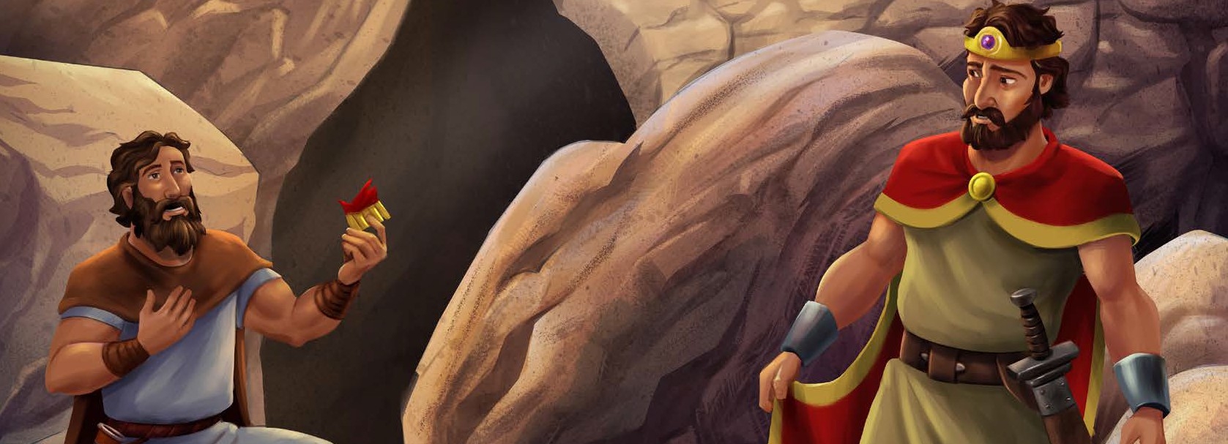
David became a great military leader for the Israelites and was more successful in battle than all of Saul’s army. Saul was very jealous of David. Saul was hunting down David to kill him, because he did not want David to become king instead of him.
While Saul and his army chased after David to kill him, Saul went into a cave to go to the bathroom. It just so happened that he went into the very cave where David and his men were hiding. Saul did not see David and the men in the cave.
The men whispered to David: “Look, the Lord has handed Saul over to you, just as He said He would.” David snuck up behind Saul while he was going to the bathroom and cut off a corner of his robe.
Afterward, David felt terrible for cutting off a corner of Saul’s robe. David said to his men: “I should have never done such a thing to a man anointed by the Lord!” The men wanted to go fight Saul, but David did not let them.
Then Saul left the cave and went on his way. David followed him out of the cave and called to him, saying, “My lord the king!” When Saul turned around, David knelt low before him and said, “Why do you listen
to the people who say I want to hurt you?
I could have killed you in the cave, but I showed mercy because you are the Lord’s anointed. See, I have the corner of your robe in my hand! I cut it off, but I didn’t kill you. I haven’t sinned against you even though you are hunting me down to take my life.”
David told Saul that God is their judge. Only God could decide what is right and rescue David from Saul. Then David said he would never harm Saul.
Saul wept and said to David, “You are more righteous than I am. You have done good to me even though I have done evil to you. May the Lord repay you with good for what you’ve done for me today. Now I know for certain you will be king over the kingdom of Israel.”
Christ Connection: Saul was trying to kill David, but David chose to show Saul mercy. When the people were killing Jesus, He showed them mercy and said, “Father, forgive them.” We all sin, but God shows us mercy through Jesus, who died for our sin and
rose again.

WELCOME TIME
Greet each preteen as he or she arrives. Use this time to collect the offering, fill out attendance sheets, build relationships, and help new kids connect to your group.

SAY Has anyone ever hurt your feelings? What did you do in response?

SAY Do you like to play hide and seek? Why? Would you rather hide or be the seeker? Why?

Be prepared to help the large group leader with one or both of the following activities. Feel free to also use these activities at the end of your small group session to fill time if you end early.

SESSION STARTER (10 minutes)
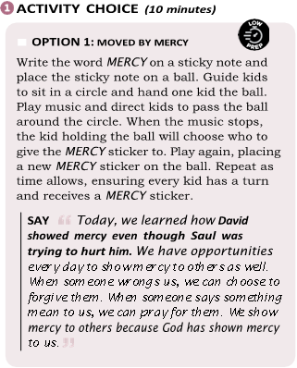

- OPTION 2: SNEAK UP
Choose one kid to be It and lead him to face a wall with his back toward the other kids. Place a blindfold on It. Guide the kids to line up on the opposite side of the room. Tell kids that they can only try to sneak up on It one at a time. If It hears a kid, he can turn around and point to where he thinks she is. Remind It to not remove his blindfold. If It is right, the kid who was caught becomes the new It. If It is wrong, the other kids take turns trying to sneak up on It. Play as time allows.
SAY Was it hard to know where someone was when you had the blindfold on? Today, we will see how David was hiding in a dark
cave because Saul was trying to hurt him. Saul didn’t know David was hiding in the cave. We’ll learn how David snuck up on Saul and cut off a piece of his robe.

TELL THE BIBLE STORY
The Bible tells us what is true about God and about ourselves. All of the stories in the Bible fit together to tell us the big story of how God rescues sinners through His Son, Jesus.
Today, we heard how David showed mercy. Through our Bible story, we learned that David showed mercy even though Saul was trying to hurt him. Whether this is your first time or your tenth time hearing this story, there is always something new to learn in God’s Word.
Read from 1 Samuel 24.

What does this story teach us about God?
David knew that it was not his place to seek revenge on Saul. David understood that God is our judge, which means only He can decide what is right and wrong. David trusted God to help him and judge Saul.

Why do you think Saul said David was more righteous than him?
Saul said that David was more righteous than him because David had done what was good to Saul even when Saul did what was evil to David. This points us to Jesus, who did what was good for others, even when people did what was evil to Him. When the
people were killing Jesus, He showed them mercy and said, “Father, forgive them.” We all sin, but God shows us mercy through Jesus, who died for our sin and rose again.

GOSPEL DISCUSSION
Even though we have sinned against God, He showed us mercy by sending His Son, Jesus, to die on the cross to pay the penalty for our sin. In Romans 6:23, we learn we deserve death for our sins, but Jesus’ death was God’s merciful act toward us. When we put our faith in Him, we receive mercy and forgiveness for our sins. Have you received God’s mercy and accepted Jesus as your Savior?

PRAY
Dear God, thank You for showing mercy to us through Your Son, Jesus, when we sin against You. Help us show mercy to others and point them to Jesus. In Jesus’ name, amen.

THE GOSPEL
GOD ’ S P L AN F OR ME

The gospel is the good news—the message about Christ, the kingdom of God, and salvation. Use Scripture and the guide provided below to explain how to become a Christian. Create an environment where kids are welcome to ask questions about what it means to follow Jesus.

GOD RULES
WE SINNED
GOD PROVIDED

JESUS GIVES

WE RESPOND

Ask: “Who is in charge at
home?” Explain that because God created everything, He is in charge of everything. Read Revelation 4:11.
Ask: “Have you ever done something wrong?” Tell kids that everyone sins, or disobeys God. Our sin separates us from God.
Read Romans 3:23.
Explain that God is holy and must
punish sin. God sent His Son, Jesus, to take the punishment we deserve.
Read John 3:16.
Ask: “What is the best gift you’ve ever received?” Say that Jesus took our punishment for sin by giving His life, and He gives us His righteousness. God
sees us as if we lived the perfect life Jesus lived. This is the best gift ever! Read
2 Corinthians 5:21.
Explain that everyone has a choice to make. Ask: “Will you trust Jesus as your Savior and Lord?
You can turn from self and sin and turn to Jesus.” Read Romans 10:9-10.

HAVE THE STUDENTS OPEN THEIR LEARNER GUIDES TO THE QUESTIONS AND FOLLOW ALONG IN THEIR GUIDES AS YOU GO OVER THE QUESTIONS (they can also answer individually and share after if you wish).

THINK ABOUT THE STORY
- What if someone was bullying us; should we bully back?
- How does the good news of Jesus change how we treat others?

GROUP DISCUSSION
Distribute Bibles. Guide preteens to open their Bibles to 1 Samuel 24. Choose a volunteer to read aloud 1 Samuel 24:11-12. Remind preteens that David had not committed a crime or
sinned against Saul. Yet, because of Saul’s jealousy, he wanted to kill David. Rather than hurt Saul, David trusted that God would judge rightly and see that Saul’s actions were wicked.
Jesus never sinned or committed a crime, and yet the people crucified Him on a cross. Not only did Jesus trust God completely, but it was God’s plan for Jesus to die on the cross to save sinners. When we trust in Jesus, we are freed from the punishment our sin deserves.
Then lead the group to discuss the following questions.

Why is jealousy a sin?
Discuss how jealousy is connected to coveting (Exodus 20:17). When we want something someone else has, we reveal what our heart desires most or what it idolizes. Saul’s jealousy lead to a murderous pursuit of David. The idol of his heart was pride and the praise of others.
(Option: Choose a volunteer to read James 4:1-7.)

Is it easy to show mercy to others when they have wronged you? Why or why not?
Answers will vary. Tell kids that it may not always be easy to show mercy to others; however, through the power of the Holy Spirit, believers can be merciful. Discuss how showing mercy also requires humility, trusting that God will judge rightly. Remind kids that we show mercy because God has shown us great mercy through Jesus. (Option: Choose a volunteer to read Micah 6:8.)

- Saul said David was more righteous than him. What makes a person righteous? Tell kids that David’s righteousness wasn’t found in himself, but in his faith in God. David was merciful because He trusted God over his circumstances. People are only made righteous through faith in Jesus (Gen. 15:6; Rom. 1:17; Gal. 2:16). Discuss how Jesus’ righteousness is given or credited to those who place their faith in Him. Explain that God not only forgives the sins of believers but also sees them as having the righteousness of Jesus. (Option: Choose a volunteer to read 2 Cor. 5:21.)

BIG PICTURE QUESTION
Is anything or anyone greater than God?
No, God is greater than everything and everyone.



LIVE
THE MISSION OF THE GOSP EL

KEY PASSAGE ACTIVITY
Instruct kids to open their Bibles to Jeremiah 10:6-7a. Lead them in reading the key passage aloud together. Form kids into pairs. Provide a kid in each pair with a piece of paper and a pen. Guide pairs to stand 6–10 feet away from one another. Lead the kids with the paper to write the first few words of the key passage on the paper. Then direct them to fold the paper into a paper airplane. Kids will toss the airplane to their partner who will then unfold it, write the next few words, and toss the airplane back. Continue until all the words have been written.

PRAY
Invite volunteers to share prayer requests. Then pray, praising God for the mercy He shows us through Jesus.

ADDITIONAL ACTIVITY

THE MERCY SEAT
Place a chair in the center of the room, and label the corners of the room 1–4. Invite a kid to sit in the chair. Play a game similar to four corners but instead of kids being out when a corner is called, they will be awarded a point. Direct the kid in the “mercy seat” to close his
eyes. Lead kids to walk to one of the corners of the room. Invite the kid in the “mercy seat” to call out a corner. Award kids in that corner a point. Play as time allows, inviting different kids to sit in the “mercy seat.” The kid with the most points wins.
Tell kids that in the Old Testament, the mercy seat was in the tabernacle in the holy of holies. The high priest would sprinkle the blood of an animal on the mercy seat to ask God for forgiveness of the people’s sin. We no longer offer sacrifices for sin because Jesus became the perfect sacrifice through His death on the cross. Now, we can freely come to God through faith in Jesus to find forgiveness and mercy (Hebrews 4:16).

