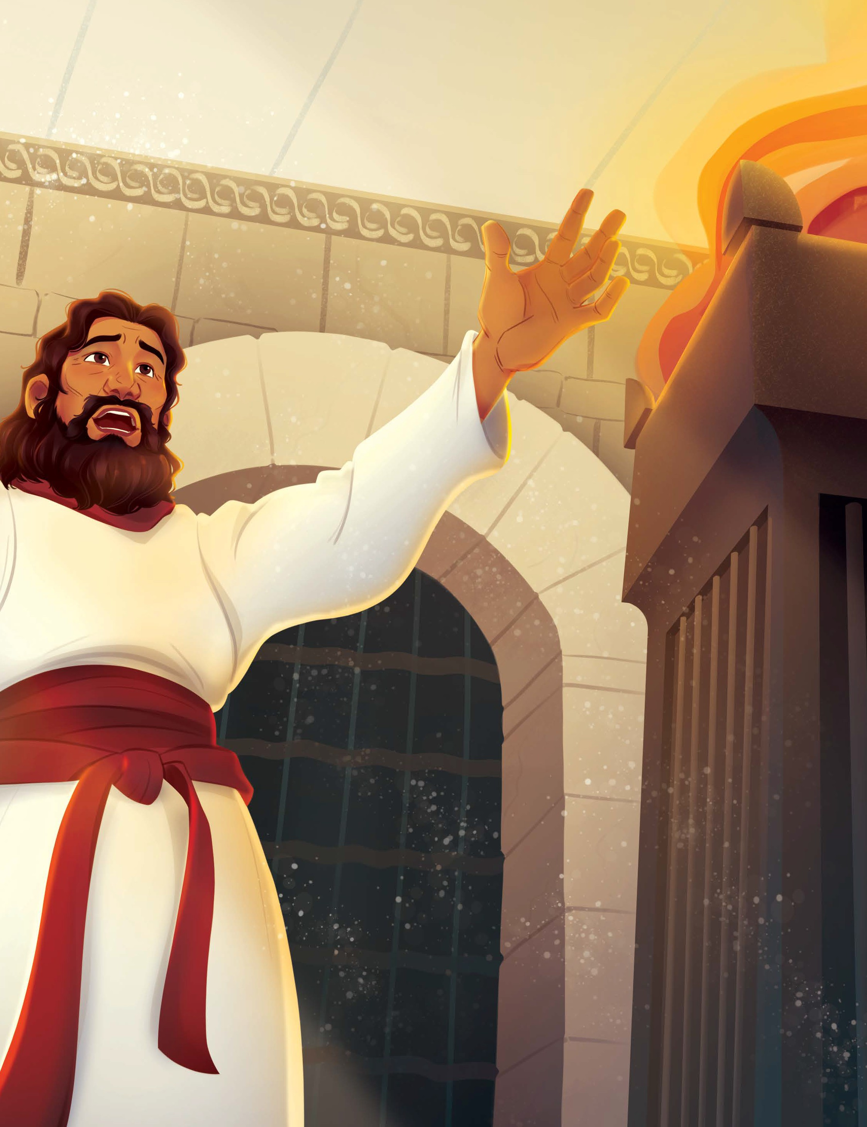
UNIT 1 2 | SESSION 1

SOLOMON BECAME KING
1 KINGS 2 – 3

KEY PASSAGE: Proverbs 3:7

BIG PICTURE QUESTION: What does God know? God knows everything about the past, present, and future.

CHRIST CONNECTION: God gave Solomon wisdom to lead His people. Jesus is wisdom, and He leads those who trust in Him to eternal life. When we follow Jesus, we become wise.

STORY POINT: God gave Solomon wisdom to lead His people.

Older Kids Leader Guide | Unit 12 • Session 1 | 94
© 2025 Lifeway

P RIOR T O TEA CHING THE SESSION


LEADER Bible Study

PREPARE
THE WEEK PRIOR
Prepare your heart to teach; plan the session
As King David neared the end of his life, he desired for his son, Solomon, to walk in God’s ways, obey His commands, and honor the Lord as he continued their family line on Israel’s throne. Though Solomon would not be a perfect king over Israel, he was able to lead the people with the wisdom he received from God. In the wisdom of King Solomon, we see a picture of the Lord Jesus Christ, the true embodiment of godly wisdom in human form.
What was the significance of Solomon asking for wisdom? How is Jesus greater than Solomon?

WELCOME
10–15 MINUTES
Greet kids and open the session
Perhaps it was David’s last words to his son which prompted Solomon to ask for wisdom. After all, when God spoke to Solomon in the dream, Solomon responded by recalling how his father walked in God’s ways. In any case, Solomon told God that he was inexperienced and just a youth. Solomon’s humble request for wisdom pleased God, and He generously bestowed Solomon with wisdom, wealth, and honor. Solomon’s request for wisdom revealed a heart that desired to esteem God by governing His people and discerning between good and evil.

LEARN
25–30 MINUTES
Teach kids the story of the gospel
Still, the wisdom of Solomon pales in comparison to the wisdom of Christ. Jesus fully embodied wisdom by perfectly fearing and obeying the Lord. Infinitely greater than Solomon is the wisdom of God’s Son, who formed the world, rules the world, and sustains the world. 1 Corinthians 1:30 tells us that Jesus, “became wisdom from God for us—our righteousness, sanctification, and redemption.” Only through Jesus can we receive the wisdom to walk in God’s ways with hearts that desire to glorify Him. When we know Jesus, we know wisdom.
Reflect on the wisdom of God offered to us through Jesus Christ. Consider His gift of wisdom in your own life as you have matured in your faith. Pray for the Lord to open children’s hearts to their need for not only wisdom, but the salvation that grows our wisdom as we continue to walk in the Lord’s ways.

Lead kids to love the God of the gospel
15–20 MINUTES
LOVE



Lead kids to live out the mission of the gospel
15–20 MINUTES
LIVE

Solomon Became King | 95

WELCOME Kids
Greet each kid as he or she arrives.
BE PREPARED TO HELP THE LARGE GROUP LEADER WITH ONE OF THE FOLLOWING ACTIVITIES as well as help the children to answer the questions.
SAY If you could ask God for anything, what would you ask Him? Why?

SESSION STARTER (10 minutes)

- OPTION 1: WISDOM OR KNOWLEDGE?
Challenge kids to determine which statement, in each pair of statements, showcase wisdom or just knowledge about something. Consider the following examples or create your own:
  - Knowing a bicycle goes fast vs. wearing a helmet while riding a bicycle
  - Following the school rules vs. reading the school rules sign
  - Seeing a dangerous situation vs. walking away from a dangerous situation
  - Knowing the crosswalk symbols vs. following the crosswalk symbols
  - Loving and obeying God vs. learning about God
SAY Wisdom and knowledge may seem the same, but they are different. Wisdom is being able to judge what is true and right while acting on that judgment. Knowledge comes from gaining information about a
subject. The Bible speaks about knowledge and wisdom because both are important. Without knowledge, we can’t grow in wisdom. Today, we will learn how David’s son, Solomon, became king and how God gave Solomon wisdom to lead His people.
- OPTION 2: ASK ME
Provide each kid with a note card and a pen. Lead kids to write an animal name on the card. Emphasize that the animal should be one others will know. Then guide kids to hand their note cards to you. Shuffle the note cards and tape one to each kid’s back. Direct kids to go around to different kids and ask them yes or no questions about
the animal they have. For example, a kid may ask, “Does my animal have fur?” Or, “Is my animal very large?” Challenge kids to continue asking other kids questions to help them determine the animal taped to their back.
SAY You couldn’t figure out the animal name on your own, could you? You each needed help from others to determine the name of your animal. Today, we will learn how Solomon, David’s son, realized he needed help leading God’s people. God invited Solomon
to ask Him for anything, and Solomon chose to ask God for wisdom so he could lead the people of Israel.





Transition from WELCOME to LEARN

Solomon Became King | 97

THE GOD OF THE GOSP EL
LOVE God by Applying the Story
ACTIVITY PAGE (5 minutes)
HAND OUT THE ACTIVITY PAGE TO BEGIN SMALL GROUP –
If you choose not to use the activity page during small group, PLEASE hand it out BEFORE parent pick-up as it has the parent information sheet attached to the coloring sheet so parents know what the children studied today.

SAY Today’s story teaches us all about where true wisdom comes from: Jesus!
REVIEW & BIBLE SKILLS (5 minutes)
Distribute Bibles, and display the Old Testament Kingdoms Map. Guide kids to open their Bibles to 1 Kings 3. Tell kids that the books of 1 and 2 Kings were originally written as one large book. Share how these books are named after the series of kings who ruled over God’s people. Explain that they fall into the History division of the Old Testament.

Choose a volunteer to read aloud 1 Kings 3:15 or ask the kids to follow along as you read the verse aloud. (consider reading the entire Bible story passage 1 Kings 3 in the Bible if time allows.)
SAY After Solomon woke up from his dream, he traveled to Jerusalem to offer sacrifices to the Lord. Solomon offered a burnt offering to symbolize a payment was required for his sin. He also offered a fellowship offering to symbolize peace between him and God. Both offerings showed that Solomon’s heart loved God and that he wanted to worship and follow God.
Like Solomon, believers’ hearts are moved to worship when they realize the great grace of God in their lives. Solomon received a gift he did not deserve, and we receive the gift of salvation when we trust in Jesus. Christians love and obey God because of His great grace in their lives.

GROUP DISCUSSION (10 minutes)
Ask the following questions. Lead the group to discuss.
SAY Why did Solomon ask God for wisdom? Why do we need wisdom?
Remind kids that Solomon realized he was too young and inexperienced to be able to lead God’s people in his own knowledge. He also recognized that God is the source of true and lasting wisdom. He wanted a heart that was able to judge between good and evil. We also need wisdom to be able to judge what is right from evil. Only a heart that has been changed by Jesus can truly be wise. (Option: Choose a volunteer to read Ps. 111:10.)
SAY Why is wisdom better than riches?
Discuss how wisdom from God leads to life. God tells us what is true: we are all sinners. He also gives us knowledge on how to be saved: trust in Jesus. When we wisely act upon that knowledge and trust in Jesus, we are saved from our sin and given eternal life.
(Option: Choose a volunteer to read Prov. 3:13-16.)
SAY How can we gain wisdom?
Encourage kids to remember that God desires to give us wisdom so we can live rightly for His glory. We can pray to God and ask, by faith, for the wisdom that only He provides. God’s wisdom helps us when we are in hard times, keeps us from evil, and helps us become more like Jesus. (Option: Choose a volunteer to read James 1:5.)

EXTRA GROUP DISCUSSION IF YOU READ ALL OF CHAPTER 3:
SAY: How did Solomon know who the baby's real mother was?
Help kids see that Solomon used the wisdom God had given him to understand what was really happening. The true mother cared more about her baby's life than getting her own way. She was willing to give up her rights to protect her child. Solomon's decision showed that God's wisdom helps us see beyond what is on the surface and understand the truth.
(Option: Choose a volunteer to read James 1:5.)

SAY: What does this story teach us about God's wisdom?
Discuss how God's wisdom is different from human wisdom. People often make decisions based on what looks right, feels right, or benefits them most. God's wisdom helps us know the truth and do what is right. Solomon's wise judgment amazed the people because they saw that God was helping him rule with justice.
(Option: Choose a volunteer to read Proverbs 2:6.)

SAY: How can God's wisdom help us make good choices today?
Encourage kids to think about everyday situations such as telling the truth, choosing good friends, obeying parents, or helping someone in need. Remind them that God gives wisdom to those who ask Him. When we trust Jesus and follow God's Word, He helps us make choices that honor Him and show love to others.
(Option: Choose a volunteer to read Ephesians 5:15-17.)

SAY: How is Jesus greater than Solomon?
Help kids understand that God gave Solomon great wisdom, but Solomon was still imperfect and sometimes made sinful choices. Jesus is the perfectly wise King who always does what is right. Jesus knows every heart, always tells the truth, and rules with perfect justice and love. Solomon's wisdom helped solve one difficult problem, but Jesus came to solve our greatest problem, our sin, by dying on the cross and rising again so we can be forgiven and have eternal life.
(Option: Choose a volunteer to read Matthew 12:42.)

You could also add this slightly more personal follow-up:
SAY: Why can we trust Jesus when we don't know what to do?
Remind kids that Jesus is wiser than anyone who has ever lived. He knows what is best for us even when situations are confusing or difficult. Because Jesus loves us and is always good, we can trust Him to guide us through His Word and help us make wise choices.
(Option: Choose a volunteer to read John 14:6 or Colossians 2:3.)
Christ Connection: Solomon showed wisdom when he judged between the two women, but Jesus is the greater and wiser King. Jesus perfectly knows every heart and rules His people with wisdom, justice, and love.


Transition from LOVE to LIVE
Older Kids Leader Guide | Unit 12 • Session 1 | 102



LIVE
THE ST OR Y OF THE GOSP EL

LIVE the Mission
ACTIVITY CHOICE (10 minutes)

- OPTION 1: WISDOM WALK
Before the activity, write the word foolish on a piece of cardstock. Then gather enough cardstock pieces for each kid and tape the cardstock in a large circle on the floor.
Invite kids to stand on a piece of cardstock. When you begin playing music, lead kids to walk around the circle. Tell kids that when you stop the music, whoever lands on foolish is out. Play as time allows, ensuring kids don’t jump over cardstock pieces once the group grows smaller.
Read Proverbs 28:26.
SAY When we choose to follow Jesus and walk in His wisdom, we are safe. This doesn’t mean we won’t ever experience hardship, but it does mean nothing can separate us from God and His love for us. Everyone who trusts in Jesus will have eternal life.

- OPTION 2: WOULD YOU RATHER?
Lead kids in a series of “would you rather” questions about various topics. For example, “would you rather have unlimited chocolate or vanilla ice cream?” “Would you rather have a kitten or a puppy as your pet?” “Would you rather be the world’s greatest guitar or piano player?” “Would you rather be able to swim like a fish or fly like a bird?” Consider inviting kids to think of a would you rather question to ask the group.
SAY Solomon had the choice to ask God for riches or honor or power, but rather than seek after those things, Solomon asked God for wisdom. God gave Solomon wisdom to lead His people. God invites us to ask Him for wisdom too. Sometimes we may be
confused at a situation before us, or we might be tempted to follow our hearts. Instead, when we ask God to help us make choices that honor Him, He is faithful to give us the wisdom we need.
JOURNAL AND PRAYER (5 minutes)
Distribute journal pages and pencils. Guide kids to think about and answer the questions listed on the page. As kids journal, invite them to share their ideas.
  - What does this story teach me about God or the gospel?
  - What does the story teach me about myself?
  - Are there any commands in this story to obey? How are they for God’s glory and my good?
  - Are there promises in this story to remember? How do they help me trust and love God?
  - How does this story help me to live on mission better?
Review the gospel, and encourage kids to speak with you or another teacher if they have questions. Then pray, thanking God that the true source of wisdom comes from following Jesus and trusting Him for salvation. As time allows, lead kids to complete “Complete It” on the activity page.

Solomon Became King | 103

