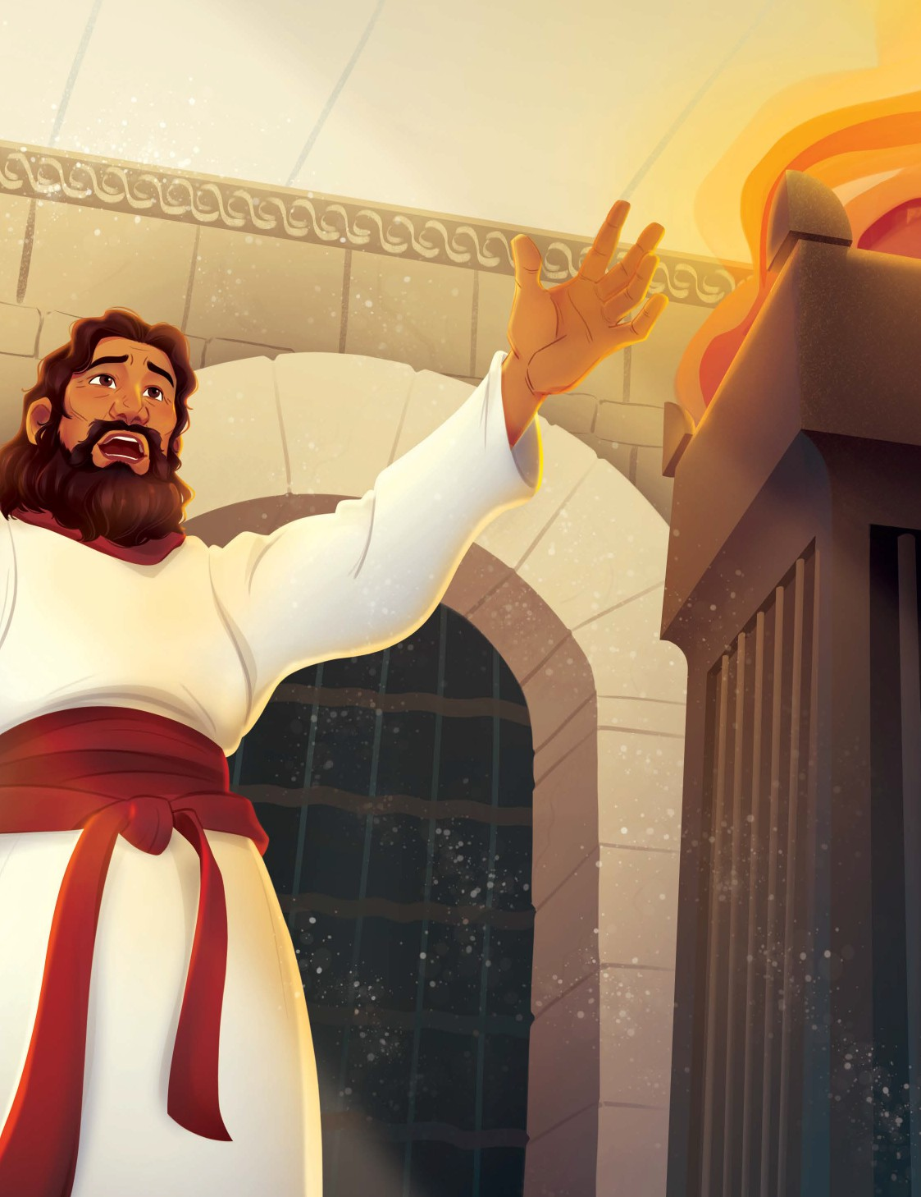
UNIT 12 SESSION 1

SOLOMON BECAME KING

1 KINGS 2 – 3

September 13, 2026 2/3 Year Olds

CHRIST CONNECTION: Solomon asked for wisdom, and God gave it to him. When we ask God for help, He will help us. God helped us in the greatest way by giving us His Son, Jesus, to rescue us from our sins.

BIG PICTURE QUESTION: What does God know? God knows everything.
KEY PASSAGE: Fear the LORD and turn from evil. Proverbs 3:7
STORY POINT: God gave Solomon wisdom.
Young


PREPARE
PRIOR TO TEACHING THE SESSION

LEADER Bible Study
As King David neared the end of his life, he desired for his son, Solomon, to walk in God’s ways, obey His commands, and honor the Lord as he continued their family line on Israel’s throne. Though Solomon would not be a perfect king over Israel, he was able to lead the people with the wisdom he received from God. In the wisdom of King Solomon, we see a picture of the Lord Jesus Christ, the true embodiment of godly wisdom in human form.
What was the significance of Solomon asking for wisdom? How is Jesus greater than Solomon?
Perhaps it was David’s last words to his son that prompted Solomon to ask for wisdom. After all, when God spoke to Solomon in the dream, Solomon responded by recalling how his father walked in God’s ways. In any case, Solomon told God he was inexperienced and just a youth. Solomon’s humble request for wisdom pleased God, and He generously bestowed Solomon with wisdom, wealth, and honor. Solomon’s request for wisdom revealed a heart that desired to esteem God by governing His people and discerning between good and evil.
Still, the wisdom of Solomon pales in comparison to the wisdom of Christ. Jesus fully embodied wisdom by perfectly fearing and obeying the Lord. Infinitely greater than Solomon is the wisdom of God’s Son, who formed the world, rules the world, and sustains the world. 1 Corinthians 1:30 tells us that Jesus, “became wisdom from God for us—our righteousness, sanctification, and redemption.” Only through Jesus can we receive the wisdom to walk in God’s ways with hearts that desire to glorify Him. When we know Jesus, we know wisdom.
Reflect on the wisdom of God offered to us through Jesus Christ. Consider His gift of wisdom in your own life as you have matured in your faith. Pray for the Lord to open children’s hearts to their need for not only wisdom but the salvation that grows our wisdom as we continue to walk in the Lord’s ways.

WELCOME
WELCOME Preschoolers
Provide as many learning activities as possible from the Love and Live sections to give preschoolers choices to learn. Incorporate the Bible story, the Christ Connection, and key passage phrase in your conversations as the preschoolers engage in learning activities throughout the session.
Use the following activity to greet children as they enter the room. Talk about the big picture question and answer. After each child completes the welcome activity, encourage him to participate in the activities provided from the Love and Live sections of the leader guide.

PLAY A SLEEPING GAME
Invite preschoolers to play a sleeping game. As children come to the group time area, help them to spread out and lay down. Prompt children to close their eyes and be quiet. Explain to children that you are going to whisper a word to them and they need to listen carefully. If they hear the word, they are to sit up. They then need to wait for you to call on them to say the word aloud. After the child correctly says the whispered word, guide the children to lie back down. Play the game as long as time allows. Words to whisper: Solomon, king, God, dream, wisdom, worship, obey.

LEARN
THE STORY OF THE GOSPEL

LEARN the Bible Story

TRY ON A CROWN
Place the step stool in the group time area and display the Bible Story Picture Poster. Stand on the stool and place the crown on your head. Invite the children to join you for a royal Bible story. As the children arrive, guide them to be seated on the floor. Then invite each child to take a turn standing safely on the stool and wearing the crown.
SAY I brought a king’s crown with me today because in our Bible story, we are going to learn about a man named Solomon who becomes a king. (Hold up the crown.) Listen carefully to hear what Solomon needed from God to make him a good king.

TELL THE BIBLE STORY
Open your Bible to 1 Kings 2–3. Tell the Bible story using the following summary. You may choose to review the Bible story by showing the video.

SOLOMON BECAME KING
SAY When King David was very old, he talked to his son Solomon and said, “Remember to be brave and do what God says. If you do, good things will happen for our family.”
When David died, Solomon became the new king of Israel.
One night, God visited Solomon in a dream. God said, “Ask me for anything, and I will give it to you.”
Solomon said, “You were kind to my father, David. You made him king, and now I am king. But I’m not sure how to be a good king. Can you help me be wise and know what is right and wrong?”
God was happy with what Solomon asked. God said, “You could have asked for anything, but you wanted wisdom. I will give you wisdom. You will be the wisest person! And I will give you riches and honor too, as long as you listen to Me.”
When Solomon woke up, he realized God spoke to him in a dream. Solomon went to Jerusalem and talked to God at the tabernacle. He gave gifts to God there.

Christ Connection: Solomon asked for wisdom, and God gave it to him. When we ask God for help,
He will help us. God helped us in the greatest way by giving us His Son, Jesus, to rescue us from our sins.

LEARN
THE STORY OF THE GOSPEL

REVIEW THE BIBLE STORY
Hold the bowl in your hands and point to the Bible Story Picture Poster. Tell the children that you are going to ask questions about the Bible story. If a child knows the answer, hand him the crown and invite him to toss it into the bowl while answering. Sample questions: When David died, who became the new king? (Solomon) When did God visit Solomon? (while he was sleeping) What did God say to Solomon in the dream? (What would you like for me to give you?) What did Solomon ask God for? (wisdom) What did God give to Solomon? (wisdom, wealth, and honor) What did Solomon give to God at the tabernacle? (gifts and offerings)
SAY God appeared to Solomon in a dream. God told Solomon that He would give him anything he wanted. Instead of asking for riches, Solomon asked God to help him be wise and know right from wrong. Solomon asked for wisdom. God gave Solomon wisdom. When we ask God for help, He will help us. God helped us in the greatest way by giving us His Son, Jesus, to rescue us from our sins.

SING A SONG
Sing the song to the familiar tune of “Are You Sleeping?”: What does God know? What does God know?
Everything, everything
There is no one like Him. There is no one like Him. Trust His way. Trust His way.

LEARN AND PRACTICE THE KEY PASSAGE PHRASE
Place the Key Passage Phrase Marker at Proverbs 3:7. Invite a child to open your Bible to the key passage. Read the phrase aloud. Learn the key passage phrase by making up motions for the words of the phrase. Say the phrase together using the motions you and the children made up.
SAY Solomon could have asked God for anything, but instead, Solomon asked God to make him wise and to know what is right and wrong. This is what it means to fear the Lord and to turn from evil.

PRAY
Pray, asking God to make us wise and to know what is right and wrong.





Transition from LEARN to LOVE

LOVE
THE GOD OF THE GOSP EL


MAKE A KINGLY CROWN
Using scissors, cut long strips of construction paper about 3 inches wide. Distribute cut strips of paper, markers, and crayons to the children and prompt children to decorate their crowns by drawing gems on them. When the children finish coloring, fit the strip to preschoolers’ heads, and connect the ends of the paper with tape.
SAY Let’s see how your kingly crowns look on you. When David died, Solomon became the new king of Israel. One night, God visited Solomon in a dream. God said, ‘Ask me for anything, and I will give it to you. God gave Solomon wisdom. When we ask God for help, He will help us. God helped us in the greatest way by giving us His Son, Jesus, to rescue us from our sins.



LIVE
THE STORY OF THE GOSPEL

LIVE for God out of love
ARRANGE POOL NOODLE WORDS
With a permanent marker write the words of the key passage phrase on the sides of cut pool noodles: Fear, the Lord, and turn, from evil., Proverbs 3:7. Place the cut pool noodles, paper towel holder, and Key Passage Phrase Marker on a table. Prompt children to match the words on the pool noodles to the key passage phrase and to put the words in order. Help the children stack the pool noodles in order on the paper towel holder.
SAY ‘Fear God and turn from evil. Proverbs 3:7’ (Point to pool noodle segments.) To fear God, is to obey and respect Him. In our Bible story, when Solomon asked God to give him wisdom so he would know what is right and wrong. He feared God and turned from evil.

TRANSITION
Remind preschoolers that the good news about Jesus is too good to keep to ourselves! God wants us to tell others about Jesus. A follower of Jesus who is sent to tell others about Jesus is called a missionary. Review and talk about the Bible story. Lead them to complete the activity page. As they work, continue talking about the Bible story and emphasize the Christ Connection.
SAY Solomon asked for wisdom, and God gave it to him. When we ask God for help, He will help us. God helped us in the greatest way by giving us His Son, Jesus, to rescue us from our sins.
Remember to communicate helpful information to the bonus teaching hour leaders. If parents are picking up children at this time, tell them something their child did well during the session. Distribute Big Picture Cards for Families. Encourage parents to engage with the family discussion starters and family activities during the week.

BONUS
TEA CHING HOUR

BONUS Teaching Hour Group Time

PLAY A SLEEPING GAME
Invite preschoolers to play a sleeping game. As children come to the group time area, help them to spread out and lay down. Prompt children to close their eyes and be quiet. Explain to children that you are going to whisper a word to them and they need to listen carefully. If they hear the word, they are to sit up. They then need to wait for you to call on them to say the word aloud. After the child correctly says the whispered word, guide the children to lie back down. Play the game as long as time allows. Words to whisper: Solomon, king, God, dream, wisdom, worship, obey.

TALK ABOUT THE BIBLE STORY
Open your Bible to 1 Kings 2–3. Use the summarized points below to talk about the Bible story:

SOLOMON BECAME KING
- Before King David died, he told his son Solomon, “Be brave and do what God says.” Then Solomon became the king of Israel.
- One night, God spoke to Solomon in a dream. God said, “I will give you anything you ask for.” Solomon wanted to be a good king. He asked God to give him wisdom.
- God was happy with Solomon. He gave him wisdom and other things too. Solomon went to the tabernacle and worshiped God.

SING A SONG
Sing the song to the familiar tune of “Are You Sleeping?”: What does God know? What does God know?
Everything, everything
There is no one like Him. There is no one like Him. Trust His way. Trust His way.

SAY THE KEY PASSAGE PHRASE
Place the Key Passage Phrase Marker at Proverbs 3:7. Invite a child to open your Bible to the key passage. Read the key passage phrase aloud. Say to the children that to fear God means listening to him and learning from Him what is right and what is wrong. This is what Solomon did in today’s Bible story. Ask children to tell you some ways that they can obey God. Invite children to lie down, close their eyes, and say the phrase with you while pretending to sleep.

PRAY
Pray, asking God to help us to obey His laws.

BONUS
TEA CHING HOUR


PLAY A PILLOW TOSS GAME
Gather the children in a circle and invite them to be seated. Hold up a beanbag and say, “This is our pretend pillow.” Gently toss the beanbag to a child and ask the child to tell you one thing he remembers from the Bible story while tossing the beanbag back to you. Repeat the process of tossing and telling with each child.
SAY We have been talking about what we are learning during the Bible story time about King Solomon. When God promised to give Solomon anything, Solomon asked God to help make him wise and to know what is right and wrong. Solomon asked for wisdom. God gave Solomon wisdom.
When we ask God for help, He will help us. God helped us in the greatest way by giving us His Son, Jesus, to rescue us from our sins.
GET A BABY DOLL READY FOR BED
In a corner of the room, lay out the dolls, doll care items, and books. Arrange the rocking chair and doll bed. Invite a child to get a baby doll ready for bed. Prompt her to do such things as put pajamas on the doll, wrap the doll in a blanket, read the doll a story, feed the doll a bottle, rock the doll in the chair, and tuck the doll into bed. As the child gets the baby doll ready for bed, encourage the child to tell you what she does to get ready for bed each night.
SAY Shh. Let’s pretend that it is nighttime, and the baby doll is sleeping. In today’s Bible story, we heard how God visited Solomon at night in a dream. God promised to give Solomon anything. Solomon asked God for wisdom. God gave Solomon wisdom. When Solomon woke up, he realized that God had spoken to him in a dream. Solomon went to Jerusalem and talked to God at the tabernacle.
MAKE A KEY PASSAGE PHRASE PILLOW
Write the key passage phrase on the front of each child’s lunch sack. Distribute sacks and invite children to decorate their sacks using crayons, markers, and stickers. When children have finished their sacks, open up the sack and show children how to stuff several sheets of paper into the sack as stuffing for their pillows. Roll the top of the sack down and tape it securely.
SAY The key passage phrase says, ‘Fear the Lord and turn from evil. Proverbs 3:7.’ While he was sleeping, God visited Solomon in a dream. God promised to give Solomon anything. Solomon asked for wisdom so he could know what is right and wrong. This is what it means to fear God and to turn from evil: to learn what is right and to do it. God gave Solomon wisdom.

Release preschoolers to parents according to your church’s security procedure. Tell them something that their child enjoyed doing or did well during the session.

