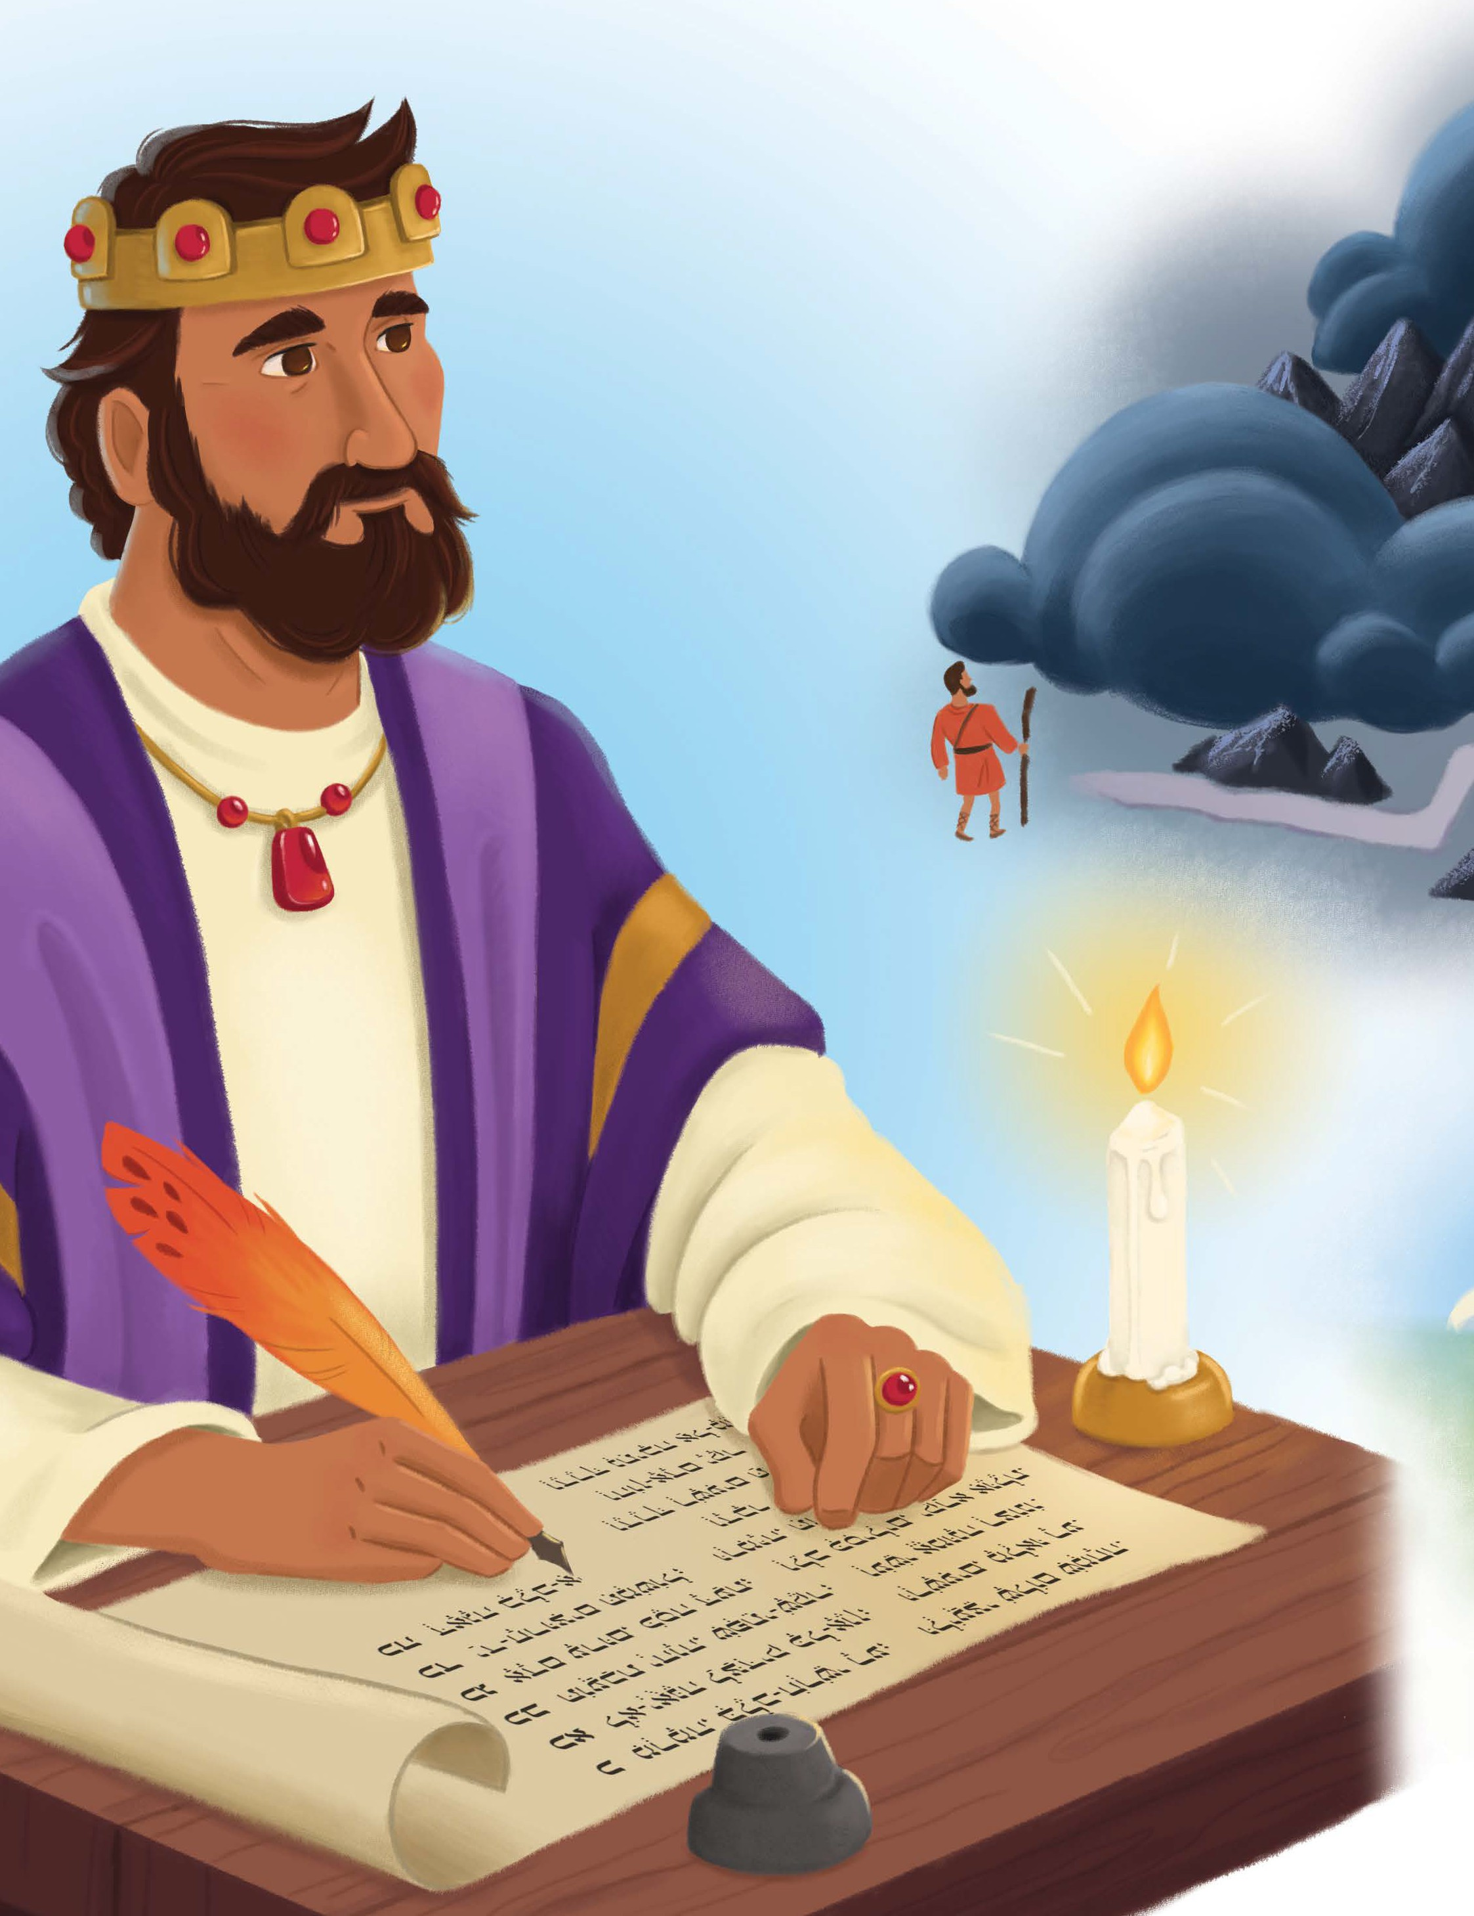
UNIT 1 2 | SESSION 5

WISDOM OF GOD’S PEOPLE

PR O VERBS 1 : 3 – 4

CHRIST CONNECTION: Solomon taught that people should trust in God. Jesus trusted in God, His Father, and followed His plan by coming to earth to die on the cross for our sins. Jesus rose again. When we trust Him, we have forgiveness and life with God forever.

BIG PICTURE QUESTION: What does God know? God knows everything.

KEY PASSAGE: Fear the Lord and turn away from evil. Proverbs 3:7

STORY POINT: We gain wisdom when we trust in God.

Older Preschool Leader Guide | Unit 12 • Session 5 | 134
© 2025 Lifeway



PREPARE
P RIOR T O TEA CHING THE SESSION


LEADER Bible Study

PREPARE
THE WEEK PRIOR
Prepare your heart to teach; plan the session
God’s gift of wisdom to King Solomon did not end with Solomon; he shared this wisdom through his proverbs. Solomon wrote in Proverbs 1:2 that these words were for learning wisdom and discipline, understanding insightful sayings, receiving instruction, and teaching the inexperienced. Through all the insight he gained as the wisest man on earth, he came back to this truth: “The fear of the LORD is the beginning of knowledge” (Proverbs 1:7).
What does it mean to fear the Lord? How can we know that we have true wisdom?

WELCOME
10–15 MINUTES
Greet preschoolers and open the session
Fearing the Lord means honoring Him as holy and revering Him as God alone. Solomon recognized the folly of a life lived in his own strength and wisdom. He knew that pursuing the Lord through genuine trust and obedience is the only way to live a life that matters. He beckoned readers to trust in the Lord with all their heart and not depend on their own understanding. The proverbs reveal to us that wisdom is not a mere intellectual exercise. Wisdom is a Person, Jesus, and by trusting in Him we find salvation.
Many proverbs offer practical guidance for interacting with the world: avoiding peer pressure, pursuing the path of peace, and treating others fairly. However, all of the practical guidance is grounded in following God’s wisdom above any earthly knowledge. Solomon wrote of the favor God’s people experience when they cling to His ways above all else.
Consider your relationship to godly wisdom. Reflect on the seasons of life that have led you closest to the Lord and in obedience to Him. Remember God’s generosity and kindness toward His followers: “Now if any of you lacks wisdom, he should ask God—who gives to all generously and ungrudgingly—and it will be given to him” (James 1:5).
Invite preschoolers to see the beauty of pursuing God’s ways and trusting Him, both for the promise of His presence and the wisdom He provides in our everyday lives. Life everlasting begins when we come to faith in Him!

Wisdom of God’s People | 135

Social/Arrival Activities (8:45-9:10) (10:30-10:55)

WELCOME Preschoolers

ACTIVITY PAGE
Lead preschoolers to complete “Find the Pair” on the Activity Page.
SAY Do any of the Bibles on the activity page look like a Bible you have seen? Even though the outsides of Bibles look different, the words on the inside are all God’s words. Because of the wisdom God gave to him, Solomon wrote down many short sayings called proverbs. We can read them in
the Bible.

SESSION STARTER
Use one or both of the following options to engage curiosity about today’s
Bible story.
PLAY OUT FAMILY LIFE
Offer preschoolers a doll house and people figures. Lead boys and girls to play out family life with the figures. Be mindful of family situations or circumstances that your preschoolers may be part of as you guide their play.
SAY Today’s Bible story will teach us some of the wise sayings God revealed to King Solomon. Solomon wrote down these proverbs, and they are in the Bible. When people read these proverbs, they will learn that we gain wisdom when we trust in God. Solomon wrote that people should be kind to others and do the things God says.

DECIDE IF YOU WANT HELP

Set up a wood piece tower game, where three wood blocks are stacked on top of each other in
crossing patterns to make a tower. Invite preschoolers to the front one at a time to remove a
piece. When each preschooler comes forward, ask them if they want your help deciding which
block to remove so the tower doesn’t fall over.

SAY “Many of you asked for my help to know which block you should choose to remove. It is wise to ask someone else for help, especially if they know more than you. That’s why Solomon said, ‘Don’t be proud and think you know everything.’ We can always look to God and follow His direction, because He knows more than all of us. What does God know? God knows everything.”

Bible Story Video/Worship Song (9:15-9:25) (11:00-11:10)

INTRODUCE THE BIBLE STORY
Cut a piece of string or yarn about 8 inches long and tie it around your finger. As you welcome boys and girls to church, move your hand in a way that preschoolers notice the string tied to your finger and ask about it.
SAY Oh, this? Sometimes I have a hard time remembering things. I tie a string around my finger to remember things like, turn off the lights, put fuel in the car, or lay out the frozen meat that will be cooked for dinner. Today, I tied this string to my finger to remember to tell my friends at church that Solomon told people how to be wise.

LEARN ABOUT THE BIBLE
Place a bookmark at Proverbs 1 in your Bible. Invite a preschooler to open it. Reverently display the open Bible.
SAY My Bible is open to the book of Proverbs. Proverbs is in the Old Testament part of the Bible, and when we read it, we are reading the things God told Solomon and other people to write down.

Point to the Bible story picture. Remind children that all the stories in the Bible fit together to tell an even bigger story. The Bible tells us the big story of how God rescues sinners through His Son, Jesus.
3. WATCH THE BIBLE STORY

CHRIST CONNECTION
SAY Solomon taught that people should trust in God. Jesus trusted in God, His Father, and followed His plan by coming to earth to die on the cross for our sins. Jesus rose again. When we trust Him, we have forgiveness and life with God forever.

Sing the key passage song, “Turn, Turn, Turn (Proverbs 3:7).”

Feel free to sing another worship song of your choice if time and interest allow.

THE ST OR Y OF THE GOSP EL

At this time, we will split the class into two groups. (The teacher should divide the kids equally – age doesn’t matter.) 1 group will remain in Room 204 with 2 volunteers to complete the craft with their group. The other group will go to Room 205 with the other 2 volunteers to do a few review activities/games. After about 15 minutes, switch groups and repeat the same process. When both groups are ready, gather all the children and volunteers together back in Room 204. At this time, the children can repeat any games or activities they enjoyed or simply have free play time until church is over.

Small Group/Bible Story Review (9:30-9:45) (11:15-11:30)

LEARN THE BIG PICTURE QUESTION AND ANSWER
SAY King Solomon was wise and wrote down pieces of wisdom to help people know what to do. Can you think of someone who knows more than Solomon? What does God know? God knows everything, and people should trust in Him. Jesus trusted God even when it meant that Jesus had to die on the cross and rise again. When we trust in Jesus, we have forgiveness and life with God forever.

PRACTICE THE KEY PASSAGE

Guide preschoolers to put the yellow plates in order, using the Key Passage Poster as a guide. Say the verse a few times as children work.
SAY These plates remind me of the rising sun King Solomon wrote about. Solomon wanted people to know how to live in a way that pleases God. When people trust God, they want to make the best choices and turn away from sin. The only way to be saved from sin is through Jesus, who came to rescue sinners so we can have life with God forever.


PLAY A “SOLOMON SAYS” GAME
Tell the children that you are going to play a game with them called, “Solomon Says,” which is similar to “Simon Says.” Instruct the children to listen carefully to what you are saying. If they hear the phrase “Solomon Says” before an instruction, they need to do the motion you tell them. However, if they do not hear you say, “Solomon Says” they need to do nothing. If a child does an action that is not preceded by “Solomon Says” gently and playfully point them out, but allow them to continue to play the game in the next round. Example actions: touch your nose, tap your foot, turn around.
SAY Did you have trouble remembering to only do the things Solomon said to do? King Solomon was wise. He wanted to help people know how to do the right things and make good choices.
Solomon taught that people should trust God. We gain wisdom when we trust in God. Jesus trusted in God, His Father, and followed His plan to rescue sinners.
PLAY A BOARD GAME
Form two or three groups of preschoolers. Lay the game boards on a flat surface for each group. Give each child a colored pom-pom to mark her path through the board. Invite a child to roll the dice, identify the number shown, and move her game piece that many spaces. Read the proverb that is printed on the space and talk about it. (Note: If possible, place an adult with each group to help preschoolers read.)
SAY Thanks, everyone, for following the game’s rules. It helped us enjoy the game. Do you remember some of the rules King Solomon wrote about? We gain wisdom when we trust in God and do what He wants us to do. God says His way is the best way to live. Jesus followed God’s ways, even when it meant that Jesus would die on the cross for our sins. Jesus rose again, and when we trust Him, we will have life with God forever because our sins have been forgiven.

LIST WHAT GOD HAS GIVEN

Invite preschoolers to share gifts from God that they enjoy, such as family, friends, church
family, food, favorite toys, and more. Make a list of these gifts from God on a dry erase board,
using a dry erase marker.

SAY “We gain wisdom when we trust in God. God shares His wisdom with us in many ways,
including through the Bible. In the book of Proverbs in the Bible, Solomon taught us to give back to God from the good things He has given us. Look at all God has given us! We can give back to Him through worship, obedience, and more!”

THE GOD OF THE GOSP EL

Craft (9:45-10:00) (11:30-11:45)

MAKE A SUN

Distribute a coffee filter and yellow or orange crayons to each child. Instruct preschoolers to completely color the coffee filter. Give each child a piece of light blue construction paper and assist them in using a glue stick to adhere the coffee filter to the paper. Lastly, demonstrate how to draw “rays” on the paper by drawing lines or triangles around the filter with the paint sticks.

SAY “When Solomon was writing the proverbs, he said that people who love God are like the sun shining brighter and brighter. These sun pictures can remind us to trust in God and follow Him so we can provide light and show others that We gain wisdom when we trust in God.”

PRAY
Invite preschoolers to close their eyes and think about God as they talk with Him.
SAY God, we praise You because You know everything. Thank You for leading Solomon to write down these words in the Bible so we can know how to make good choices. Thank You that You sent Jesus to die on the cross and rise again so that when we trust in Him, our sins are forgiven, amen.

1st service volunteers, Please remember to set up the arrival activities for the children who will be attending second service. Also, reset any games or activities in room 205 that will be needed. Thank you!

