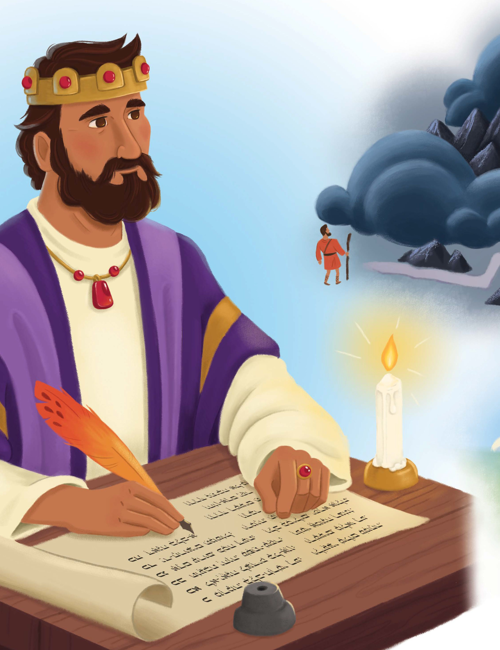
UNIT 1 2 | SESSION 5

WISDOM OF GOD’S PEOPLE

PR O VERBS 1, 3 – 4

CHRIST CONNECTION: Solomon taught that people should trust in God. Jesus trusted in God, His Father, and followed His plan to rescue sinners. When we trust in Jesus, we have forgiveness and life with God forever.

BIG PICTURE QUESTION: What does God know? God knows everything. KEY PASSAGE: Fear the LORD and turn awayfrom evil. Proverbs 3:7 STORY POINT: We gain wisdom when we trust in God.

Younger Preschool Leader Guide | Unit 12 • Session 5 | 134
© 2025 Lifeway



PREPARE
P RIOR T O TEA CHING THE SESSION


LEADER Bible Study

PREPARE
THE WEEK PRIOR
Prepare your heart to teach; plan the session
God’s gift of wisdom to King Solomon did not end with Solomon; he shared this wisdom through his proverbs. Solomon wrote in Proverbs 1:2 that these words were for learning wisdom and discipline, understanding insightful sayings, receiving instruction, and teaching the inexperienced. Through all the insight he gained as the wisest man on earth, he came back to this truth: “The fear of the LORD is the beginning of knowledge” (Prov. 1:7).

WELCOME
10–15 MINUTES
Greet preschoolers and open the session
What does it mean to fear the Lord? How can we know that we have true wisdom?
Fearing the Lord means honoring Him as holy and revering Him as God alone. Solomon recognized the folly of a life lived in his own strength and wisdom. He knew that pursuing the Lord through genuine trust and obedience is the only way to live a life that matters. He beckoned readers to trust in the Lord with all their heart and not depend on their own understanding. The proverbs reveal to us that wisdom is not a mere intellectual exercise. Wisdom is a Person, Jesus, and by trusting in Him we find salvation.
Many proverbs offer practical guidance for interacting with the world: avoiding peer pressure, pursuing the path of peace, and treating others fairly. However, all of the practical guidance is grounded in following God’s wisdom above any earthly knowledge. Solomon wrote of the favor God’s people experience when they cling to His ways above all else.
Consider your relationship to godly wisdom. Reflect on the seasons of life that have led you closest to the Lord and in obedience to Him. Remember God’s generosity and kindness toward His followers: “Now if any of you lacks wisdom, he should ask God—who gives to all generously and ungrudgingly—and it will be given to him” (James 1:5).
Invite kids to see the beauty of pursuing God’s ways and trusting Him, both for the promise of His presence and the wisdom He provides in our everyday lives. Life everlasting begins when we come to faith in Him!

WELCOME

Social/Arrival Activities (8:45-9:10) (10:30-10:55)

WELCOME Preschoolers


MAKE A SNAKE WITH PLAY DOUGH
Write a capital S on a piece of paper. Distribute play dough to the preschoolers. Show preschoolers how to roll the play dough on a tabletop into long, thin snakes. Point to the letter S and challenge the children to bend their play dough snakes into an S shape.
SAY Solomon starts with the letter S. King Solomon was very wise. He wrote down short sayings called proverbs. Proverbs help us know how to do the right things and make good choices. Solomon taught that people should trust in God. We gain wisdom when we trust in God. Jesus trusted in God, His Father, and followed His plan to rescue sinners. When we trust in Jesus, we have forgiveness and life with God forever.
PLAY OUT FAMILY LIFE
Offer preschoolers a doll house and people figures. Lead boys and girls to play out family life with the figures. Be mindful of family situations or circumstances that your preschoolers may be part of as you guide their play.
SAY Today’s Bible story will teach us some of the wise sayings God revealed to King Solomon. Solomon wrote down these proverbs, and they are in the Bible. When people read these proverbs, they will learn that we gain wisdom when we trust in God. Solomon wrote that people should be kind to others and do the things God says.

FOLLOW THE PATH

Prior to the session, use painters’ tape to make different paths across the room. One path
should be a straight line, but the others should zig zag and curve, with fun, creative patterns.
Invite preschoolers to walk across the room on the different lines or use toy cars to follow the
different paths.
SAY “There were many ways to walk across the room following those paths. But one way was the straight path. There are many ways we can live our lives. Solomon says there is one best way: follow the wisdom of God, be honest, be true, and be kind to others. We gain wisdom when we trust in God.”

LEARN
THE ST OR Y OF THE GOSP EL

Bible Story Video/Worship Song (9:15-9:25) (11:00-11:10)

PLAY A MAKING CHOICES GAME
Display the Bible Story Picture Poster in the group time area. Greet the preschoolers in group time and invite children to be seated. Show the children how to make a “thumbs up” and a “thumbs down.” Say to the children that you are going to make several statements. If the statement is a good choice, then instruct the children to give a “thumbs up.” If not, then give a “thumbs down.” Statements to use: The boy obeyed his parents and picked up his toys. (up)The girl hit her brother. (down) The child shared his cookie with his friend. (up) The boy disobeyed his teacher when asked to help. (down) The girl let another child take a turn riding her bike. (up) The child did not come when his mother called. (down)
SAY It’s important to make good choices. Today, we are going to learn about a Bible book named Proverbs. In this book, King Solomon wrote some sayings that help us to make good choices.

WATCH THE BIBLE STORY

CHRIST CONNECTION
SAY Solomon taught that people should trust in God. Jesus trusted in God, His Father, and followed His plan by coming to earth to die on the cross for our sins. Jesus rose again. When we trust Him, we have forgiveness and life with God forever.

Sing the key passage song, “Turn, Turn, Turn (Proverbs 3:7).”

Feel free to sing another worship song of your choice if time and interest allow.

LEARN
THE ST OR Y OF THE GOSP EL

REVIEW THE BIBLE STORY
Point to the Bible Story Picture Poster. Ask children to tell you what they see. Then, tell the children that you will read several statements from the Bible story. If the statement is true, instruct children to give a “thumbs up.” If not, instruct children to give a “thumbs down.” Use the following statements (all are true): King Solomon wrote many short sayings called proverbs. Solomon wrote that we should respect God. Solomon said to be kind to others.
Solomon said to trust God with all your heart. Solomon said to stay away from what is wrong. Solomon said God corrects us when we do something wrong because He loves us.
SAY All of these statements are true! Solomon wrote many proverbs to help people know how to make good choices. Solomon taught that people should trust in God. We gain wisdom when we trust in God. Jesus trusted in God, His Father, and followed His plan to rescue sinners. When we trust in Jesus, we have forgiveness and life with God forever.

Craft (9:25-9:35) (11:10-11:20)

MAKE A SUN

Distribute a coffee filter and yellow or orange crayons to each child. Instruct preschoolers to completely color the coffee filter. Give each child a piece of light blue construction paper and assist them in using a glue stick to adhere the coffee filter to the paper. Lastly, demonstrate how to draw “rays” on the paper by drawing lines or triangles around the filter with the paint sticks.

SAY “When Solomon was writing the proverbs, he said that people who love God are like the sun shining brighter and brighter. These sun pictures can remind us to trust in God and follow Him so we can provide light and show others that We gain wisdom when we trust in God.”

LOVE
THE GOD OF THE GOSP EL

Group/Bible Story Review (9:35-10:00) (11:20-11:45)

PASS THE SCROLL
Invite children to be seated in a circle in the group time area. Play worship music and prompt children to pass the scroll as the music plays. When the music finishes, prompt the child holding the scroll to unroll it, say the key passage together and then roll it back up again. Play the passing game as time allows.
KEY PASAGE – FEAR THE LORD AND TURN AWAY FROM EVIL. PROVERBS 3:7

PLAY A “SOLOMON SAYS” GAME
Tell the children that you are going to play a game with them called, “Solomon Says,” which is similar to “Simon Says.” Instruct the children to listen carefully to what you are saying. If they hear the phrase “Solomon Says” before an instruction, they need to do the motion you tell them. However, if they do not hear you say, “Solomon Says” they need to do nothing. If a child does an action that is not preceded by “Solomon Says” gently and playfully point them out, but allow them to continue to play the game in the next round. Example actions: touch your nose, tap your foot, turn around.
SAY Did you have trouble remembering to only do the things Solomon said to do? King Solomon was wise. He wanted to help people know how to do the right things and make good choices.
Solomon taught that people should trust God. We gain wisdom when we trust in God. Jesus trusted in God, His Father, and followed His plan to rescue sinners.

SING A SONG
Sing the song to the familiar tune of “Are You Sleeping?”: What does God know? What does God know?
Everything, everything
There is no one like Him. There is no one like Him. Trust His way. Trust His way.

First Service Volunteers, please remember to set up arrival activities for the children who will be attending second service. Thank You!

