UNIT 1 3 | SESSION 4

THE REIGN OF AHAB

1 KINGS 2 0 – 2 2 ; 2 KINGS 1

CHRIST CONNECTION: Ahab disobeyed God and was punished. We deserve punishment for our sin, but when we trust in Jesus, God does not give us the punishment our sins deserve.
Jesus died on the cross so we can have forgiveness and life with God forever.

BIG PICTURE QUESTION: How many gods are there? There is one true God.

KEY PASSAGE: May all people know the LORD is God. There is no other! 1 Kings 8:60

STORY POINT: Ahab disobeyed God and was punished.

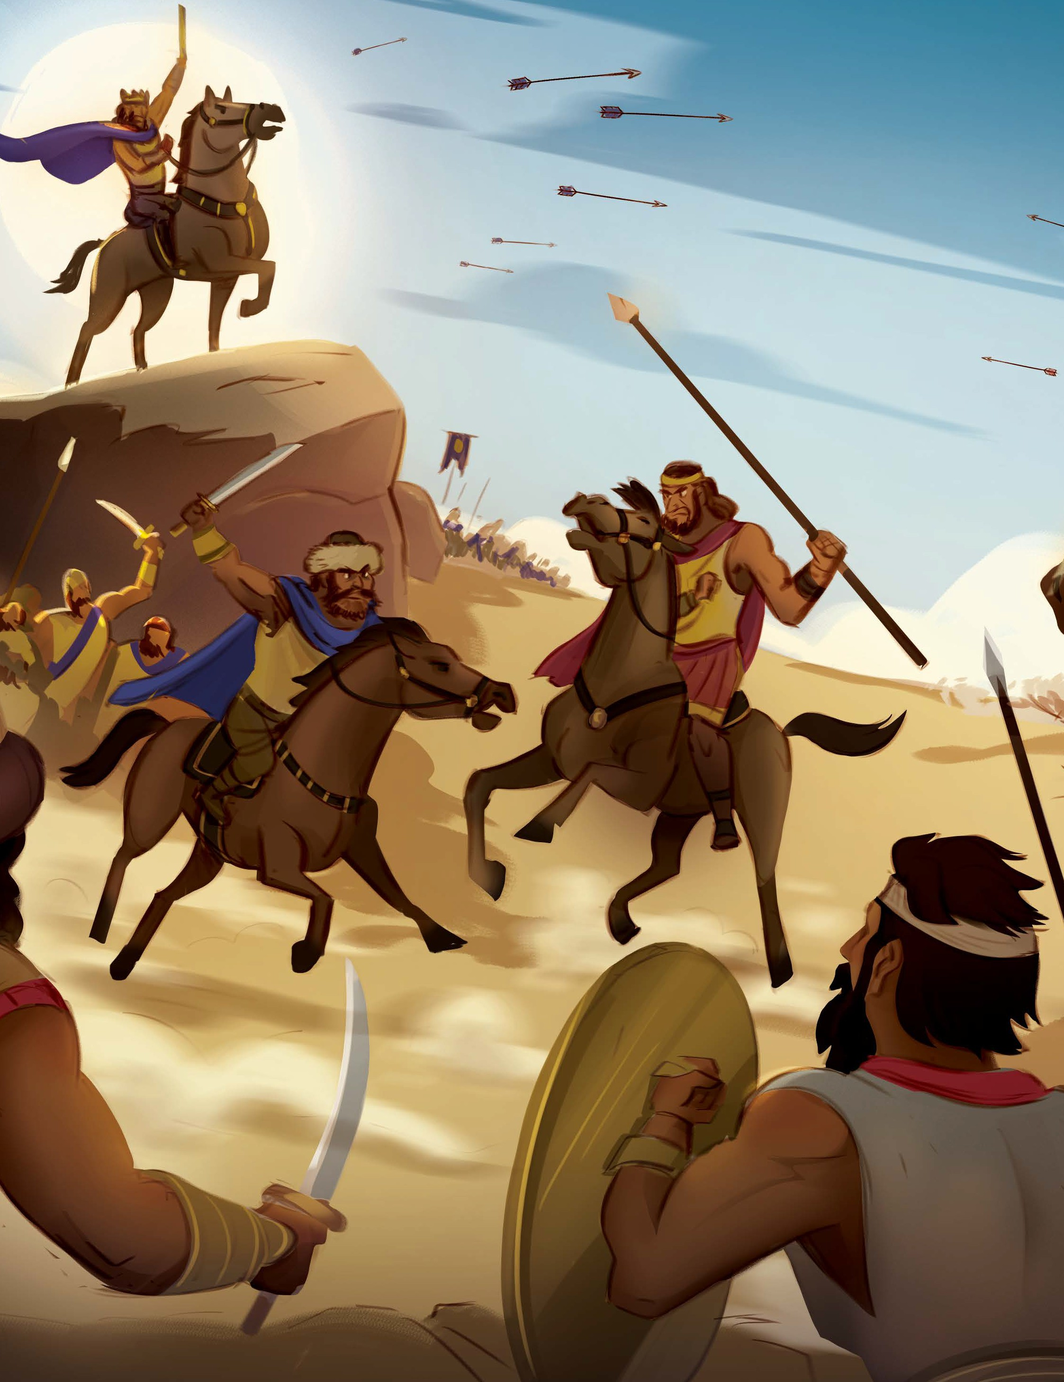
© 2025 Lifeway
Older Preschool Leader Guide | Unit 13 • Session 4 | 36



PREPARE
P RIOR T O TEA CHING THE SESSION


LEADER Bible Study

PREPARE
THE WEEK PRIOR
Prepare your heart to teach; plan the session
Have you ever heard the expression “you reap what you sow”? Perhaps you feel the burn of those words as you think of times you made a hasty decision or took matters into your own hands, only to later watch things fall apart. In today’s text, Ahab made a series of poor choices which ultimately led to his demise.
First, the Lord gave King Ahab victory over the Arameans—not once, but twice—to remind Ahab that He is the Lord. When Israel won the second battle, they captured Ben-hadad, but Ahab disobeyed God and agreed to a treaty, releasing Ben-hadad.

WELCOME
10–15 MINUTES
Greet preschoolers and open the session
Second, a man named Naboth owned a vineyard that caught Ahab’s interest. In his greed, Ahab and his wife Jezebel developed a wicked scheme to take Naboth’s vineyard. Their deception turned murderous when hired men lied about Naboth, saying he had cursed God and the king. Naboth was falsely convicted and sentenced to death.
A few years later, Ahab wanted to go to war against the Arameans once again. Ahab’s false prophets supported his decision, but Micaiah, a prophet of the true God, advised against it, since going to war against Aram would fail. Once again, Ahab acted stubbornly and went to war anyway. During the battle, he was struck by an arrow and died.
While God showed Ahab patience and gave him many warnings, Ahab ultimately refused to repent. Like Ahab, we can be greedy and stubborn. In our sin, we rebel against God and act according to our flesh. The Bible tells us that the wages of sin is death, but the gift of God is eternal life through Jesus (Romans 6:23). Jesus lived a perfect life and died in the place of sinners so that we might be forgiven and be made right with God.
Encourage boys and girls to see that because Christ laid down His life for us, we can escape the punishment we deserve because of our sin. Teach preschoolers that when we believe in Jesus and repent of sin, Christ removes our unrighteousness and changes our hearts so that we desire to follow God and His ways.

Social/Arrival Activities (8:45-9:10) (10:30-10:55)

ACTIVITY PAGE
Lead preschoolers to complete “Our Good King” on the Activity Page.
SAY We have been learning about the kings of Israel. Were most of them good kings or bad kings? [Allow responses.] Many of the kings did not obey God. They even led the people away from God. I’m so thankful God gave us a perfect King, His Son, Jesus.

SESSION STARTER
Use one or both of the following options to engage curiosity about today’s Bible story.

MAKE CARS GO UP AND DOWN
Prior to the session, cut cardboard pieces into ramps of various lengths and sizes. Invite
preschoolers to use the blocks to create buildings and roads. Guide preschoolers to use the
cardboard to make ramps that the cars can go up and down on. Free play with cars.

SAY “The roads you built were flat, but we used the ramps to make hills for the cars to go up and
down. The Israelites were used to living and fighting in the hills, which is why King Ben-hadad thought
he could defeat God’s people if they fought in the flat plains instead. But the Israelites did not win
because of the hills; they won because the one true God was on their side. How many gods are there?
There is one true God.”

CREATE HILLS AND VALLEYS

Lead kids to sit at a table. Squirt a small amount of shaving cream in front of each child, invite preschoolers to spread out the cream, and use their finger to draw hills and valleys. Help older preschoolers write words such as God, Jesus, and obey. (Note: Allow children with sensory sensitivities to draw with a craft stick or an unsharpened pencil.)

SAY “It looked like you had fun making hills and valleys with the shaving cream! God’s people lived
in the hills and were used to fighting on the hills. That’s why the enemy army thought that they could
win if they fought on the flat plains instead. God told Ahab to destroy the enemies of God’s people, but
Ahab did not obey God. Ahab disobeyed God and was punished. Jesus perfectly obeyed God. Jesus
died on the cross and rose again so we can have forgiveness and life with God forever.”

DRAW DRY ERASE BOARDS
Offer dry boards and dry erase markers to several preschoolers and lead them to draw pictures on them. Suggest a child draw a picture of a crown that a king might wear. Ask a child to draw a picture of hills and mountains, or a beautiful field. Encourage a child to think about Jesus and the gift of forgiveness that God gives us through Jesus before drawing a self-portrait. Keep paper towels nearby so the children can easily wipe their boards clean and start again.
SAY You drew pictures of some things from today’s Bible story. I see a mountain and a crown. Today we learned that Ahab disobeyed God and was punished. Just like King Ahab, we deserve punishment for our sin. But when we trust in Jesus, God does not give us the punishment we deserve. Instead, we can have life with God forever because Jesus died on the cross and rose again. What a wonderful gift!

THE ST OR Y OF THE GOSP EL

Bible Story Video/Worship Song (9:15-9:25) (11:00-11:10)

INTRODUCE THE BIBLE STORY
Ask preschoolers if they have ever created a wish list. Explain that a wish list is created by
listing items that a person might like to receive as gifts. Talk about how a person might react if the thing they wanted most was not gifted to them.

SAY “Sometimes people make lists of things they would like to receive as gifts. But just because
an item is on your list does not mean another person will buy it for you. In today’s Bible story, King
Ahab wanted something badly, and he was upset because he did not get it. So he and his wife did
something terrible. Listen closely to hear what King Ahab and his wife did.”

LEARN ABOUT THE BIBLE
Place a bookmark at 1 Kings 20 in your Bible.
SAY Today’s true story is found in the book of 1 Kings in the Old Testament part of the Bible. God told men to write the words we will read in today’s Bible story.

WATCH THE BIBLE STORY VIDEO & SING WORSHIP SONG
(KEY PASSAGE SONG IS “No Other Kings”)
Please practice “Away in the Manger” for our Christmas program on December 13.

CHRIST CONNECTION
SAY Ahab disobeyed God and was punished. We deserve punishment for our sin, but when we trust in Jesus, God does not give us the punishment our sins deserve. Jesus died on the cross so we can have forgiveness and life with God forever.

At this time, we will split the class into two groups. (The teacher should divide the kids equally – age doesn’t matter.) 1 group will remain in room 204 with 2 volunteers to complete the craft with their group. The other group will go to room 205 with the other 2 volunteers to do a few review activities/games. After about 15 minutes, switch groups and repeat the same process. When both groups are ready, gather all the children and volunteers back in room 204. At this time, the children can repeat any games or activities they enjoyed or simply have free play time until church is over.

THE ST OR Y OF THE GOSP EL

Small Group/Bible Story Review (9:30-9:45) (11:15-11:30)

LEARN THE BIG PICTURE QUESTION AND ANSWER
SAY Ahab worshiped idols and did not honor God. How many gods are there? There is one true God. King Ahab was disrespectful and disobedient to God. Ahab was an evil king, and God punished him. Even though we sin and deserve God’s punishment, when we trust in Jesus we can have forgiveness and life with God forever.

REVIEW
Ask the following review questions:
1. What did you like about the Bible story? (Answers will vary.)
2. What were some things in the Bible story that made you happy or sad? (Answers will vary.)
3. What did Ahab choose to do when God told him not to go to war again? (Ahab did not listen to God.)
4. What was the consequence for Ahab’s disobedience? (Ahab died during the battle. Ahab disobeyed God and was punished.)
5. Who took the consequences for our sin by dying and rising again? (Jesus lived a perfect life, died the death we deserve to die, and rose again so that we could be forgiven and saved.)
6. How many gods are there? There is one true God.

SAY “Ahab was a selfish, evil king. Ahab did what he thought was best, not what God thought was best. God told Ahab to punish the king of the enemies of God’s people, but Ahab let him go instead. Then Ahab’s wife lied and had a man named Naboth killed so that Ahab could take his land. Finally, Ahab refused to listen to God when God told him not to go to war again. Ahab disobeyed God and was punished. Even though we sin, God has made the way for us to be saved through trusting in His Son, Jesus.”

PRACTICE THE KEY PASSAGE
Place the Key Passage Marker at 1 Kings 8:60. Invite a child to open your Bible to the key passage. Read the key passage aloud. Urge all the boys to repeat the first half of the key passage, and the girls to recite the last half. Lead children to use the call-and-response method, switching assignments, until the group can say the passage from memory.
SAY God gave King Ahab several chances to follow Him. Even when Ahab heard that the Lord is God—there is no other, Ahab chose to disobey God. Thankfully, when we trust in Jesus, God does not give us the punishment we deserve for our sin.

May all the people of the earth know that the LORD is God. There is no other! 1 Kings 8:60

(If time allows…Sing the key passage song, “No Other (1 Kings 8:60).” You may also choose to sing a worship song of your choice.)
LISTEN AND MATCH
Print the “Geography Cards” printable on heavy paper and cut along the dashed lines. Use the cards to play a traditional BINGO-like game. Give boys and girls a game board and craft pom-poms or large buttons to use as game pieces. Place a set of individual geography cards (calling cards) in a gift bag. Choose a card from the bag, talk about the geographical features, and instruct children to cover the space on the game boards. (Note: The printable can also be used as a matching game by printing two copies of the calling cards.)
SAY King Ahab battled against Ben-hadad and the Aramites. They fought in the hills and won the battle. Then they fought on the flat land, and they won that battle too. God helped them win to show Ahab that the Lord is God. But Ahab disobeyed God anyway. Ahab disobeyed God and was punished. God still punishes sin, but He also made the way for our sin to be forgiven. When we trust in Jesus, who died on the cross and rose again, we can have forgiveness and live forever with God.

KNOCK DOWN MOUNTAINS
Arrange preschoolers into two lines. Using disposable cups, create two tall mountains opposite of each line. Give the first child in each line a beanbag. Encourage preschoolers to toss the beanbag toward the cup mountain. After each toss, assist preschoolers to the back of the line so the next teammate may toss. Celebrate as each team knocks down their mountain.

SAY “King Ahab battled against Ben-hadad. Ahab’s army fought in the mountains and won the
battle. Then they fought on the flat land, and they won that battle, too! God helped them win to
show Ahab that the Lord is God. But Ahab disobeyed God and was punished. God still punishes
sin, but He also made the way for our sins to be forgiven. When we trust in Jesus, who died on the
cross and rose again, we can have forgiveness and life with God forever.”

THE GOD OF THE GOSP EL

Craft (9:45-10:00) (11:30-11:45)

LOVE God because of what we learned

DECORATE A CROSS

Distribute a cross and washable markers to each child. Encourage children to decorate their crosses. Review the Bible story as the kids decorate their crosses.

SAY “I love seeing these crosses! In today’s Bible story, we learned that Ahab disobeyed God and was punished because He did not listen to God. Everyone, including you and me, do things that are against what God wants. That’s called sin. We all deserve punishment for our sin. But Jesus came and lived a perfect life, died on a cross, and rose again, so we could be saved. Place your cross in a window or on the refrigerator so you can see it each day and remember the good news about Jesus.”

PRAY
Invite preschoolers to close their eyes and think about God as they talk with Him.
SAY God, I’m so thankful that You sent Jesus to take the punishment for our sin. Because of Jesus, we can have forgiveness and life with You forever. Amen.

First Service Volunteers, please remember to set up arrival activities for the children who will be attending second service. Thank You!

