UNIT 1 3 | SESSION 4

THE REIGN OF AHAB

1 KINGS 2 0 – 2 2 ; 2 KINGS 1

CHRIST CONNECTION: Jesus came to take the punishment we deserve for our sins. When we trust in Jesus, God forgives us, and we will live with Him forever.

BIG PICTURE QUESTION: How many gods are there? There is one true God.

KEY PASSAGE: May all people know the LORD is God. There is no other! 1 Kings 8:60

STORY POINT: Ahab disobeyed God and was punished.

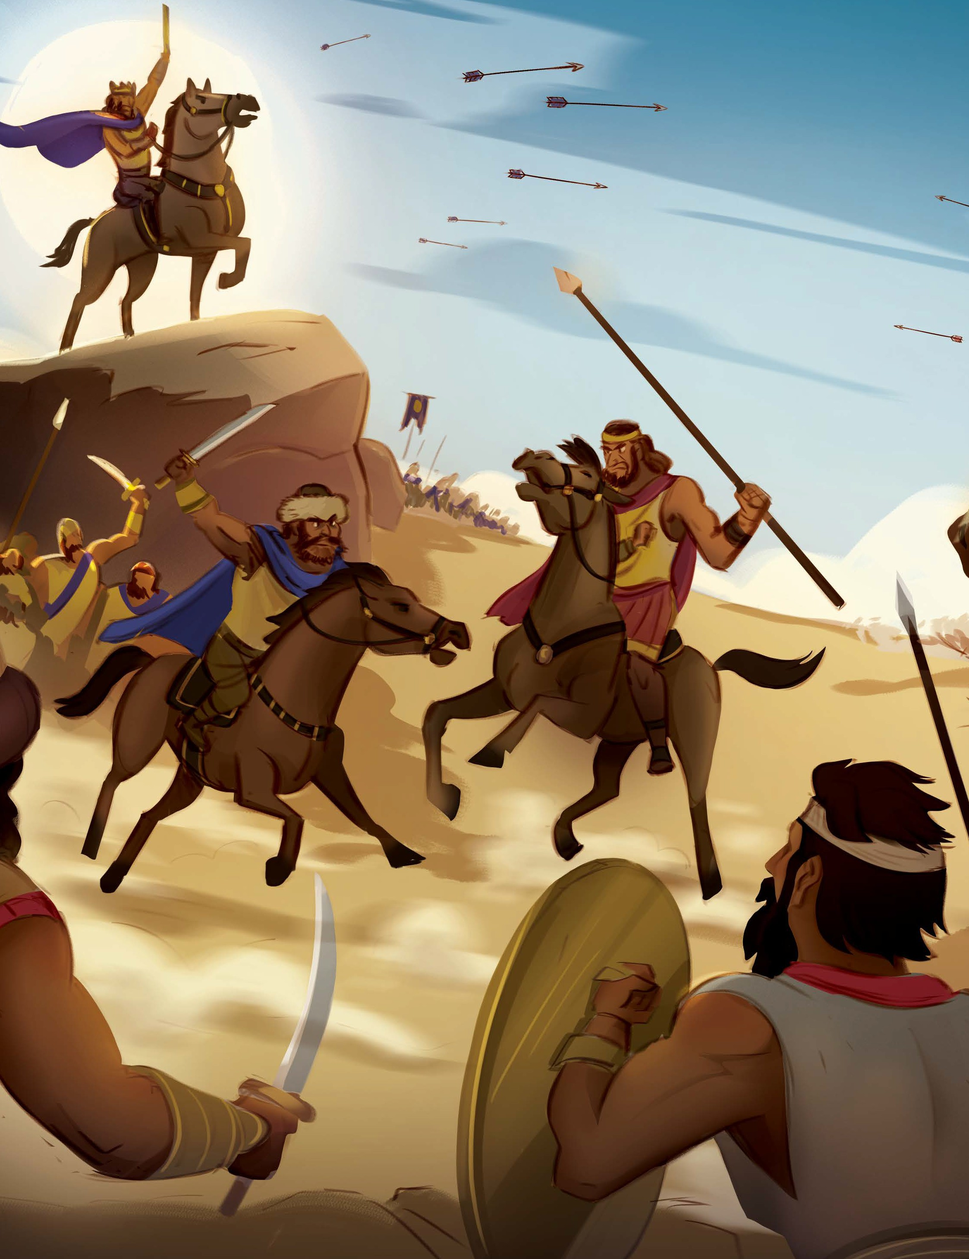
© 2025 Lifeway
Younger Preschool Leader Guide | Unit 13 • Session 4 | 36



PREPARE
P RIOR T O TEA CHING THE SESSION


LEADER Bible Study

PREPARE
THE WEEK PRIOR
Prepare your heart to teach; plan the session
Have you ever heard the expression “you reap what you sow”? Perhaps you feel the burn of those words as you think of times you made a hasty decision or took matters into your own hands, only to later watch things fall apart. In today’s text, Ahab made a series of poor choices which ultimately led to his demise.

WELCOME
10–15 MINUTES
Greet preschoolers and open the session
First, the Lord gave King Ahab victory over the Arameans—not once, but twice—to remind Ahab that He is the Lord. When Israel won the second battle, they captured Ben-hadad, but Ahab disobeyed God and agreed to a treaty, releasing Ben-hadad.
Second, a man named Naboth owned a vineyard that caught Ahab’s interest. In his greed, Ahab and his wife Jezebel developed a wicked scheme to take Naboth’s vineyard. Their deception turned murderous when hired men lied about Naboth, saying he had cursed God and the king. Naboth was falsely convicted and sentenced to death.
A few years later, Ahab wanted to go to war against the Arameans once again. Ahab’s false prophets supported his decision, but Micaiah, a prophet of the true God, advised against it, since going to war against Aram would fail. Once again, Ahab acted stubbornly and went to war anyway. During the battle, he was struck by an arrow and died.
While God showed Ahab patience and gave him many warnings, Ahab ultimately refused to repent. Like Ahab, we can be greedy and stubborn. In our sin, we rebel against God and act according to our flesh. The Bible tells us that the wages of sin is death, but the gift of God is eternal life through Jesus (Romans 6:23). Jesus lived a perfect life and died in the place of sinners so that we might be forgiven and be made right with God.
Encourage boys and girls to see that because Christ laid down His life for us, we can escape the punishment we deserve because of our sin. Teach preschoolers that when we believe in Jesus and repent of sin, Christ removes our unrighteousness and changes our hearts so that we desire to follow God and His ways.


Social/Arrival Activities (8:45-9:10) (10:30-10:55)
BUILD HILLS
Invite preschoolers to use blocks to build hills and mountains. Challenge preschoolers to build tall hills and shorter hills. Ask them to build a hill using five blocks, and then build a hill with eight blocks.
SAY Would you rather spend time in the mountains or at the beach? Where would you rather go hiking—in a field or through the hills? [Allow responses.] Today we will hear about a battle that happened in the hills. The Israelites won the battle in the hills and then fought another battle in an area where the land was flat, like a field.
DOT PAINT FRUIT
Provide each child with an activity sheet. Provide children green, purple, and red dot paints. Allow children to add color to the fruit using the dot paints.
SAY King Ahab wanted Naboth’s vineyard. But the vineyard was not for sale. So Jezebel told lies about Naboth and had him killed. Then Ahab took the vineyard. A few years later, Ahab wanted to fight Ben-hadad again. This time, God was not going to help him win. He sent a prophet to tell Ahab not to go to war. If he did, he would die. Ahab did not listen. Ahab was hit by an arrow and died.
Ahab disobeyed God and was punished. Jesus came to take the punishment we deserve for our sins. When we trust in Jesus, God forgives us, and we will live with Him forever.
LISTEN AND MATCH
Play a matching game with the cards provided. Depending on the children’s skill level, you may want to place the cards picture side facing up rather than down.
SAY King Ahab battled against Ben-hadad and the Aramites. They fought in the hills and won the battle. Then they fought on the flat land, and they won that battle too. God helped them win to show Ahab that the Lord is God. But Ahab disobeyed God anyway. Ahab disobeyed God and was punished. God still punishes sin, but He also made the way for our sin to be forgiven. When we trust in Jesus, who died on the cross and rose again, we can have forgiveness and live forever with God.

THE ST OR Y OF THE GOSP EL

Bible Story Video/Worship Song (9:15-9:25) (11:00-11:10)

WATCH THE BIBLE STORY VIDEO & SING WORSHIP SONG
KEY PASSAGE SONG IS “No Other”
Please practice “Away in the Manger” for our Christmas program on December 13.

REVIEW THE BIBLE STORY
Display the Bible Story Picture Poster within view of preschoolers. As you view the picture, talk through Ahab’s disobedient choices. Discuss with children the wise choices Ahab could have made instead.
SAY Ahab disobeyed God and was punished. The first two battles with Ben-hadad were victories for Ahab because God helped him. After Ahab let Ben-hadad go and Jezebel took the vineyard from Naboth, God sent a prophet to tell Ahab if he went to battle again he would die. Ahab disobeyed God and went to battle against Ben-hadad anyway. Ahab died just as God had said. When we sin against God, there are consequences. Jesus came to take the punishment we deserve for our sins. When we trust in Jesus, God forgives us, and we will live with Him forever.

LEARN AND PRACTICE THE KEY PASSAGE PHRASE
Place the Key Passage Phrase Marker at Psalm 1 Kings 8:60. Invite a child to open your Bible to the key passage. Read the key passage phrase. Lead children to say the key passage phrase while marching like soldiers.

May all people know that the LORD is God. There is no other! 1 Kings 8:60
SAY How many gods are there? There is one true God. Our passage phrase reminds us ‘May all people know the LORD is God. There is no other! 1 Kings 8:60’ Ahab did not worship God as the only god. Ahab disobeyed God and was punished.

THE GOD OF THE GOSP EL

LOVE God because of what we learned

Craft (9:25-9:35) (11:10-11:20)

DECORATE A CROSS

Draw a simple cross outline and write Jesus died for our sins on each toddler’s paper. Invite the toddlers to use the stickers and/or stamps to decorate the cross. Review the Christ Connection as the toddlers work.

SAY “Who died on the cross for our sins? Yes, Jesus! Jesus died for our sins. When we trust in Jesus, we will live with Him forever.”

PRAY
Pray, thanking God for always keeping His promises and for sending Jesus to be our Savior.


Group/Bible Story Review (9:35-10:00) (11:20-11:45)

SCORE POINTS
Form preschoolers into a line. Place a shallow bin opposite the line, forming a goal. Give the first child in line a beanbag. Encourage preschoolers to toss the beanbag into their goal, scoring points for their team. After each toss, assist preschoolers to the back of the line so the next teammate may toss. Keep score with each toss and play as time allows.
SAY God helped Ahab fight and win against Ben-hadad. Later, Ahab disobeyed God by letting Ben-hadad go free, and Ahab’s wife stole a vineyard from Naboth. Because of this, God sent
a prophet to tell Ahab that he would die if he went to war. Ahab disobeyed God and was punished. Jesus came to take the punishment we deserve for our sins. When we trust in Jesus, God forgives us, and we will live with Him forever. That is the greatest victory!
KNOCK DOWN MOUNTAINS
Arrange preschoolers into two lines. Using disposable cups, create two tall mountains opposite of each line. Give the first child in each line a beanbag. Encourage preschoolers to toss the beanbag toward the cup mountain. After each toss, assist preschoolers to the back of the line so the next teammate may toss. Celebrate as each team knocks down their mountain.
SAY King Ahab battled against Ben-hadad. Ahab’s army fought in the mountains and won the battle. Then they fought on the flat land, and they won that battle, too! God helped them win to show Ahab that the Lord is God. But Ahab disobeyed God and was punished. God still punishes sin, but He also made the way for our sins to be forgiven. When we trust in Jesus, who died on the cross and rose again, we can have forgiveness and life with God forever.
First Service Volunteers, please remember to set up arrival activities for the children who will be attending second service. Thank You!

