Unit 10 | Session 4

SAMUEL ANOINTED DAVID
1 Samuel 16

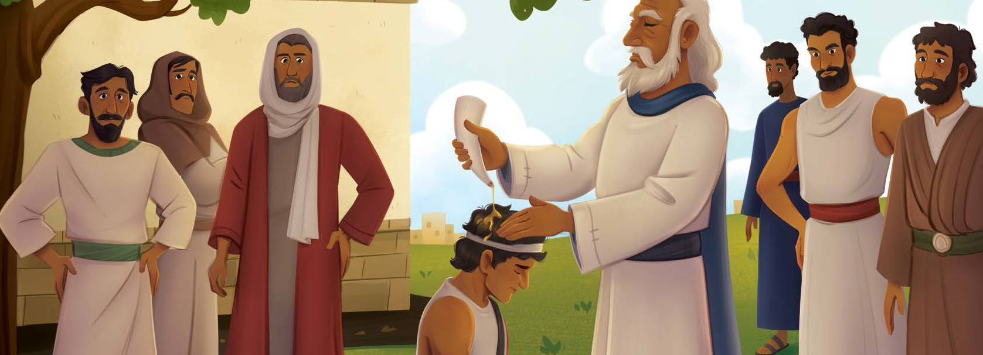
The Lord said to Samuel, “How long are you going to be sad that I have rejected Saul as king of My people? Go to Jesse of Bethlehem, because I have selected a king
from one of his sons. Bring your oil to anoint him.”
Samuel was afraid that Saul would hear about the anointing and kill him! The Lord said, “Take a young cow with you and say, ‘I have come to sacrifice to the Lord.’ Then invite Jesse to the sacrifice, and you will anoint for me the one I show you.”
Samuel did as the Lord said. When Jesse and his sons arrived, Samuel saw the oldest—Eliab—and said, “Certainly this is the king the Lord has selected for himself.”
But the Lord said to Samuel, “Do not look at his appearance or his height, because I have rejected him. Humans do not see what the Lord sees, for humans see what is visible, but the Lord sees the heart.”
Next, Jesse called his son Abinadab and presented him to Samuel. Samuel said, “The Lord hasn’t chosen this one either. Next, Jesse presented his third son, Shammah, but Samuel again said that the Lord did not choose this son.
Jesse presented seven sons to Samuel.
Samuel said, “The Lord hasn’t chosen any of
these. Do you have any other sons?” “Yes, my youngest son, but he’s out
tending the sheep,” Jesse said.
Samuel replied, “Send for him. We won’t sit down to eat until he gets here.” Jesse sent for David.
When Samuel saw David, the Lord said, “Anoint him, for he is the one.” Samuel took the oil and anointed David in the presence of his brothers. The Spirit of the Lord came powerfully on David from that day forward.
Christ Connection: David did not look like a king on the outside, but God saw his heart and chose him to be the next ruler. Jesus looked like an ordinary man to the people around Him, but He is God’s Son and the Savior of the world.

WELCOME TIME
Greet each preteen as he or she arrives. Use this time to collect the offering, fill out attendance sheets, build relationships, and help new kids connect to your group.
- Have you ever helped pick out fresh fruits or vegetables from a grocery store or market?
- What do you look for when picking the best fruits or vegetables?

BE PREPARED TO HELP THE LARGE GROUP LEADER WITH THE FOLOWING ACTIVITIES AS NEEDED:

SESSION STARTER (10 minutes)

- OPTION 1: NOT IT RELAY RACE Second
Before this session, place a basket of eight balls at the start line for each group of eight kids. Direct kids in each group to line up one behind the other. When you say, “Go,” direct the first kid in each line to carry a ball across the room and hand it to you.
When you receive the ball say, “this one is not it.” Then direct the kids to run back to their team and send the next kid who will repeat the same steps. Challenge kids to work together to get the entire basket of balls across the room, one at a time. When the eighth and final ball from the groups reaches you say, “This one is it.” The team who is the first to bring the eighth ball to you is the winner. (Tip: place a basket at your feet to collect all of the balls.)
SAY Today, we will learn how God sent Samuel to find a new king over Israel. We’ll see how Samuel went to a man named Jesse, who lived in Bethlehem. Jesse presented seven of his sons to Samuel, but God hadn’t chosen any of them to be king. Finally, Jesse presented his youngest son, David. God chose David to be king over Israel.
- OPTION 2: WHAT’S INSIDE? FIRST
Before the session, gather four paper bags of various sizes, making sure one is smaller than the rest. Place candy in the smallest paper bag. Ask kids what they think is inside of each paper bag and invite them to share their thoughts. Ask kids which bag they would choose to keep. Reveal the contents of each bag, showing how only the small
bag had the candy. Offer a piece of candy to each kid.
SAY We might think the biggest packages have the best gifts inside, and they might.
But we can’t judge something by the way it looks on the outside. People often look at the way a person looks, rather than focusing on a person’s character. Today, we’ll learn how
God told Samuel, ‘Humans do not see what the Lord sees, for humans see what is visible, but the Lord sees the heart.’

TELL THE BIBLE STORY
The Bible tells us what is true about God and about ourselves. All of the stories in the Bible fit together to tell us the big story of how God rescues sinners through His Son, Jesus.
Today, we are going to hear how Samuel anointed David. Through our Bible story, we will learn that God chose David to be king over Israel. Whether this is your first time or your tenth time hearing this story, there is always something new to learn in God’s Word.

Read from 1 Samuel 16:1-13.
Have the Students fill in their LEARNER GUIDES and follow along as you answer the following questions individually or as a group.

What does this story teach us about God?
God told Samuel that He was not looking for a king who had an impressive appearance, but a king who had a heart that pleased Him. God told Samuel to anoint David because he was the one God had chosen. David did not look like a king on the outside, but God saw his heart and chose him to be the next ruler. Jesus looked like an ordinary man to the people around Him, but He is God’s Son and the Savior of the world.

What happened to David after he was anointed with oil?
The Holy Spirit came upon David, empowering him to lead God’s people. Jesus, our perfect and forever King, was always filled with the Holy Spirit and accomplished the work of God through the Spirit’s power (Acts 10:38). When we trust in Jesus, God gives us the Holy Spirit, and we are set apart to do the good works He calls us to (1 John 2:20,27).

Form groups of two or three and practice retelling the Bible story in your own words. Think of someone you could share the story with this week.

GOSPEL DISCUSSION
God chose David to be king over Israel, but He sent Jesus to be the Savior of the world. When we trust in Jesus, we are forgiven of our sin and given new life. If you have not trusted in Jesus as your Savior, please let me know if you have any questions about what it means to follow Him.

PRAY

Thank You, Lord, for sending Jesus to live a perfect life in our place and die on the cross, taking the punishment our sin deserves. Help us have hearts and lives that please You. In Jesus’ name, amen.
Explain that everyone has a choice to make. Ask: “Will you trust Jesus as your Savior and Lord?
You can turn from self and sin and turn to Jesus.” Read Romans 10:9-10.

THINK ABOUT THE STORY
- Why is Jesus the Messiah? What is a Messiah?
- What Bible stories, like David being anointed as king, point to Jesus as the Messiah?

GROUP DISCUSSION
Distribute Bibles. Guide preteens to open their Bibles to 1 Samuel 16. Choose a volunteer to read aloud 1 Samuel 16:7. Remind preteens that when the people chose Saul as their king, they looked at his outward appearance, especially noticing how he was a head taller than everyone else. But when God chose David as king, He looked at David’s heart. In 1 Samuel 13:14, Samuel spoke about the king God would choose and said, “The Lord has found a man after his own heart.” This didn’t mean David was sinless. But David had a heart of faith that pleased God.
Then lead the group to discuss the following questions.

Why do you think people focus so much on outward appearances?
Answers will vary. Discuss how people’s focus on outward appearances reveals what their heart seeks after. For example, people who are drawn to those who are wealthy might seek after money. Or those who focus on physical beauty may desire to be with people who the world idolizes.
(Option: Choose a volunteer to read 1 Sam. 16:7.)

How can we have a heart that pleases God?
Tell kids that Jesus said, “For where your treasure is, there your heart will be also” (Matt. 6:21). Explain that God is pleased with a heart that treasures Him above all else. We can show we treasure God by our faith in Him and how faith in Him leads us to obey Him. (Option: Choose a volunteer to read Acts 13:22.)

How does the Holy Spirit help us live for God?
Remind kids that after David was anointed, the Holy Spirit came powerfully upon him. Share how the Holy Spirit indwells all who trust in Jesus as Savior. Explain how the Holy Spirit gives us power to live for God by helping us turn away from sin, remember God’s words, and share the gospel with others.
(Option: Choose a volunteer to read Acts 1:8.)

BIG PICTURE QUESTION
Who is our King?
Jesus is our King forever, and He rules over the world.



LIVE
THE MISSION OF THE GOSP EL

KEY PASSAGE ACTIVITY
Instruct kids to open their Bibles to Psalm 103:19. Lead them in reading the key passage aloud together. Form kids into two groups, and give each group a set of sticky notes and pens.
Direct the groups to each write a word from the key passage on individual sticky notes. Then lead groups to scatter the sticky notes on a wall. Guide groups to swap places, and challenge them to place the sticky notes in the correct order of the key passage. The first group to do so wins.

PRAY
Invite volunteers to share prayer requests. Then pray, praising God for Jesus and how He laid down His life to save us.

ADDITIONAL ACTIVITY

THE GOOD SHEPHERD
Scatter 100 or more cotton balls around the room. Explain that the cotton balls represent “sheep.” Form kids into pairs and distribute a cup to each pair. Tell kids they will be “shepherds” who need to collect sheep. Direct pairs to collect 10 sheep. Pairs who do not collect 10 sheep are out. Play several more times, leading kids to collect 15, 20, and 25 sheep.
Then read Psalm 78:70-72 and John 10:11-15. Discuss how David was a shepherd boy who tended the sheep of his father’s pasture. When God chose David as king, David became the shepherd over God’s people. Tell kids that Jesus is even greater than King David because He is the Son of God who laid down His life for His people.
Remind kids that God chose David to be king over Israel, but King Jesus rules forever.
Jesus is the better Shepherd who leads those who trust in Him to eternal life. King David was a good king, but he could never bring salvation. Only Jesus can forgive our sin.

